You’ll find a product page with all my programs here:

<http://challengeworkouts.com/special-offer-for-all-challenge-workout-programs>

Here’s your affiliate link to the page:

http://[AFFILIATE.1ruckus.hop.clickbank.net/?id=challengex](http://affiliate.1ruckus.hop.clickbank.net/?id=challengex)

**Subject line:** Best fitness trend?

*I want to introduce you to an older woman:*

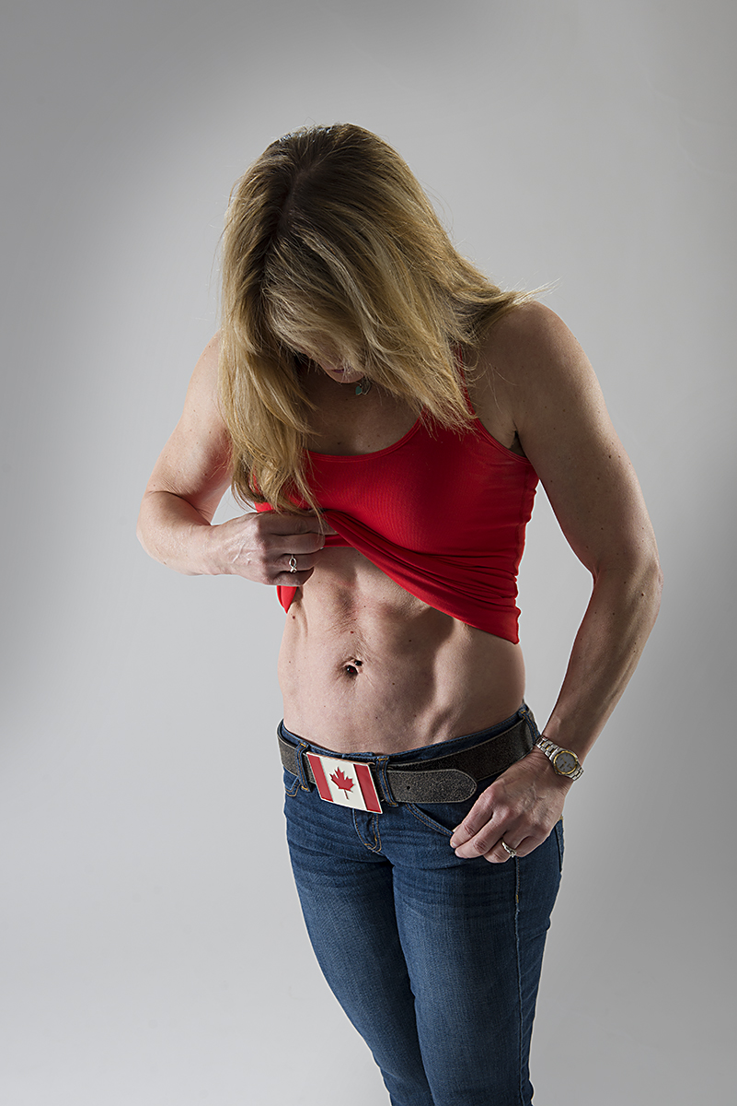<= **hyperlink your affiliate link to the pic too**

**http://challengeworkouts.com/wp-content/uploads/2014/02/fitnessshot-1.jpg**

*Yes, not what you’d expect….This is my friend, Shawna K who just turned 51 years old and she looks like this year round, this is an untouched photo.*

*Fat loss trends come and go and Shawna K has seen it all during her days. Given that Shawna has a few years in the fitness trenches, I thought I’d let her share a few thoughts on the latest fitness trends. Take it away Shawna….*

**TOP 10 Fitness Trends**

Shawna Kaminski

**ChallengeWorkouts.com** <= **hyperlink your affiliate link here**

Most people get on the bandwagon of the 'fitness flavor of the month' and never meet their fat loss goals.

Let's go through the TOP 10 popular fat loss methods. The measuring stick here is whether these workouts are effective enough to cause a noticeable body transformation evidenced with inches and pounds lost.

10. **Diet alone** - Diets work. People lose weight on diets and can temporarily become smaller versions of their former self. They often get 'skinny-fat' and are disappointed that through diet alone they haven't achieved the body of their dreams. Their metabolism usually tanks, they start eating more and gain more weight than they originally needed to lose. Bottom line: diets don't work long term.

9. **Walking** (and other 'low intensity' activities) - People mistake basic movement for exercise. Too many people think that just being 'upright' and moving will burn enough calories to make a difference and cause a body transformation. Walking is better than sitting or lying down, but not much.

8. **Zumba** (and other 'dance related' workouts) - I know this will cause a stir and Zumba enthusiasts will protest. Zumba is FUN. But let's not confuse fun with fitness benefits that will cause enough metabolic mayhem to produce a body transformation. Recreation? Yes. Fitness go-to? No. This is great as a 'day off' workout.

7. **Running** - How many people resolve to get fit and immediately decide to run a marathon? Have you seen the physique of marathon runners? It may not be what you're aspiring to. Running will get your heart fit, but will do little to transform your physique so that you're ready for the beach. If skinny-fat, no muscle tone or upper body shape and repetitive use injury risk is what you're going for, then running is for you.

6. **Big box gym 'classes'** - While gyms have good intentions with their fitness classes you'll be lost in the crowd. You'll be given a 'one size' fits all program that won't take into account your fitness level, limitations or goals.

5. **Traditional bodybuilding** - Muscle is where it's at to build metabolism and get sexy shape, but unless you were born to the right parents and are genetically gifted, traditional bodybuilding workouts will fall short. How many people go to the gym and look the SAME as the day they started? They may lift more weight on their bicep curl, but overall their body won't look like they're ready to hit the stage anytime soon.

4. **Crossfit style training** - This style of training is getting closer to the intensity needed to affect change. The lack of progressive programming is the downfall of this program. Again, this will raise hell with avid 'cross-fitters' but you can't argue with the number of injuries incurred with any crossfit style workout.

3. **Boot camp style training** - This is hit or miss depending on the actual program. Some programs are BANG ON with 30 minute workouts that are basically personal training in a group setting. Others? Not so much. Depending on the boot camp you attend, this can be one of the BEST workouts or it can set you up for an injury waiting to happen. Good luck with this one.

2. **P90X style training** - Good programming...if you have A LOT of time. You'll get variety and intensity, paired a with nutrition plan. As well, follow along videos are a great bonus to teach you exercise form. But who has the kind of time required for this workout plan?

1. **M2A or muscle metabolism acceleration** - The beauty of this workout is that it's short but intense. The idea is to combine strength training and high intensity intervals with incomplete recovery. Loads of calories are burned during the workout, but then 'afterburn' kicks into effect to keep your metabolism stoked for up to 36 hours. M2A taps into the anaerobic energy system to stimulate lactic acid. If you didn't know, lactic acid is a powerful precursor to growth hormone and GH (growth hormone) is diabolical in the fight against fat. Since adults are well past the age where they'll experience a natural boost in GH, this is one of the best ways to burn fat and build muscle.

One of the number one objections to any fitness program is 'I don't have time'. The good news with M2A is that workouts are done in 20 minutes or less.

Don’t fall for the ‘flavor of the month’ in fitness. You simply need to resistance train and get a QUICK sweat on several times a week.

Everyone has 20-30 minutes if health is really a priority.

************************************************

*There you have it.*

*It’s clear that Shawna knows what she’s doing. I’ve met her and she’s the real deal. You can take a look at her programs and start letting her systems work for you, no matter what your age.*

*Want to know more about M2A? 🡺 click here*

*If you want to be coached in follow along videos click here*

*If you like to jump rope, click here*

*Want to try the toughest exercise around? click here*

*If you like hard core BB/DB/KB exercises, click here*

*Are you're over 40 and need some encouraging workouts to get you going? click here*

Sign off