[AFFILIATE.1ruckus.hop.clickbank.net/?id=cdiet](http://AFFILIATE.1ruckus.hop.clickbank.net/?id=cdiet" \t "_blank)

**Email 1 Wed Mar 5 am**

**Subject line:** Breakthrough ‘Non-Diet Diet’

Hi, I'm Shawna K, author of ‘The 21 Day Challenge Diet’ and I know what you’re thinking: Not another diet.

Especially one named ‘Challenge Diet’.

Isn’t healthy eating hard enough without adding an additional ‘challenge’ to it?

Hold on, I want to tell you about a ‘**non-diet diet’**. You can read about it here.

Numerous people have asked me how I still have visible abs at the age of 50.



<http://challengeworkouts.com/wp-content/uploads/2014/02/fitnessshot-1.jpg>

Do I diet? NO.

What do I do then?

The best way to get into the best shape ever is to STOP dieting.

I’m all for that BUT we all know that your abs are made in the kitchen (and not just during your workout) so, how can I be saying to STOP dieting?

This was the birth of ‘The 21 Day Challenge Diet’. I just wrote out the program that I use to help me get lean and STAY lean, (even halfway to 100).

Honestly, it hasn’t been really ‘challenging’ for me to maintain the eating habits I share with you over the long haul. And with some direction, it won’t be for you either when you follow my simple guidelines.

That’s the main point with this plan. The nutrition part of it is basically a cinch. In fact, beta testers of the plan couldn’t eat all that I suggested on some days. Hunger wasn’t an issue. Energy levels weren’t an issue.

Look what Bruce had to say:

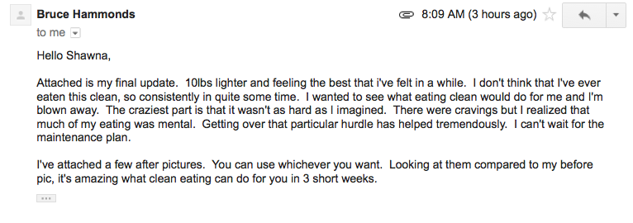

<http://challengeworkouts.com/wp-content/uploads/2014/02/bruce-h-email-testi.png>

Bruce, and others in the beta test group LOVED the plan and GOT RESULTS.

Now Bruce was pretty typical with a 10 lb loss, but others lost up to 15 lbs in the first 21 days.

For veteran dieters, you know that the concern is… ‘will it come right back on?’

Breaking news: Most beta testers that followed the 21-day maintenance plan did NOT maintain their weight.

**In fact, they LOST a few more pounds and additional inches eating even more healthy food than they did in the first 21 days.**

So what’s the ‘challenge’ with the 21 Day Challenge Diet?

It’s the ‘secret sauce’ that goes along with healthy eating.

It’s called: ‘get off your butt and move’.

WAIT! You’ll get support to do this!

I’ll be in your inbox daily to provide easy to follow home workouts and motivation. You’ll also get social support from a community of like-minded people from all over the world that are going along step by step with you.

If you want to go on a ‘non-diet diet’ that guarantees results when you do it, then read more about it here.

Stop dieting, stop counting calories, stop killing your metabolism.

Start doing the things that work to get you into the best shape of your life. Do things that are based on scientific principles, that are SENSIBLE and SUSTAINABLE.

The 21 Day Challenge Diet really isn’t that ‘challenging’ at all, unless you find that feeling energized and looking better than ever is tough work.

**Remember, it’s ONLY 21 days.**

Sign off

[AFFILIATE.1ruckus.hop.clickbank.net/?id=cdiet](http://AFFILIATE.1ruckus.hop.clickbank.net/?id=cdiet" \t "_blank)

**Email 2 (pm) Wed Mar 5 pm**

**Subject:** Get this “Secret Sauce” behind this 21-day challenge

Want the secret sauce to losing your belly fat once and for all?

If you want to be in your bathing suit this spring break, then this is your answer.

You’ll get the perfect plan that’s TOTALLY FREE for you today when you grab ‘The 21 Day Challenge Diet’ plan.

Now I know what you’re thinking: I don’t want a ‘challenge’ where my diet is concerned. It’s enough of a challenge.

The point of ‘The 21 Day Challenge Diet’ is to MOVE for 21 days along with making some nutritional changes.

You’ll get the blueprint on just how to do that as a BONUS when you grab this lifestyle changing eating plan today.

The nutrition plan is NOT the challenge. My good friend, Shawna K, who rocks year round abs at the age of 50 has eaten this way for years day in and day out.

She put together a beta test group and the results and feedback she got was amazing:

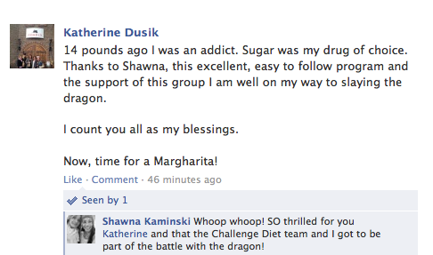

<http://challengeworkouts.com/wp-content/uploads/2014/02/ch-diet-fb-21-keeper.png>

Make sure to check out ‘The 21 Day Challenge Diet’ by midnight tonight and get the bonus workout plan that will have you looking sexy by spring break.

**Start the 21-Day Challenge right here**

Sign off

[AFFILIATE.1ruckus.hop.clickbank.net/?id=cdiet](http://AFFILIATE.1ruckus.hop.clickbank.net/?id=cdiet" \t "_blank)

**Email 3 Thurs Mar 6 am**

**Subject**: Why you need to “give in” to peer pressure [STUDY]

Did you know that peer pressure can be a good thing?

A study from Harvard showed that participants that used social support while losing weight were more successful than those who didn’t.

**In fact, the average weight loss among participants who used support was 20 pounds compared to 9 pounds!**

So if you’re looking to lose a few pounds or get your abs to pop by spring break, then listen up.

My good friend, Shawna K has a program that offers something that NO other plan does: **peer pressure.**

With the exclusive **21 Day Challenge Diet plan**, you’ll have access to an entire community of other people just like you, that will ‘pressure’ you and hold you accountable to your fat loss goals.

Do you want to:

* Eat normal food (including your favorites)
* NEVER have to rely on a “breakthrough” pill or powder
* Quickly drop up to 5 pounds in the first 7 days
* Learn how to KEEP off any weight loss FOREVER with simple strategies that won’t consume all your time
* Destroy all cravings for your favorite cookies at night and all other junk food
* Be a role model for your children, or even your grandchildren
* Eat out without having to stress about what you’ll get from the menu to “stay on course”
* Feel great in the clothes that you really want to wear without ever having to wonder if others are looking at you funny

In just 21 days, you’ll be surprised at how far you’ll come. Look at what Bruce had to say:

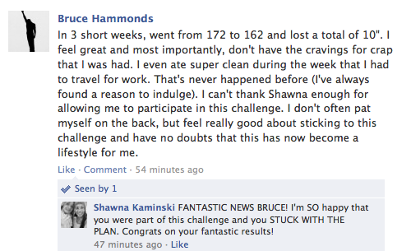

<http://challengeworkouts.com/wp-content/uploads/2014/02/ch-diet-fb-22-use-this.png>

Don’t let spring break pass you by while you sit in long sleeves and long pants. Get ready to put on your bathing suit.

Check out ‘The 21 Day Challenge Diet’ plan here.

Sign off

[AFFILIATE.1ruckus.hop.clickbank.net/?id=cdiet](http://AFFILIATE.1ruckus.hop.clickbank.net/?id=cdiet" \t "_blank)

**Email 4 (pm) Thurs Mar 6 pm**

**Subject**: The #1 “Quick” Fat Loss Meal

Eating on the run is a fact of life.

How on earth do you make good choices without blowing your nutrition?

My friend, Shawna K, a hard body at the age of 50, has a free bonus ’53 Smoothies’ for you when you grab her **’21 Day Challenge Diet’ plan tonight**.

If you want to:

* Eat normal food (including your favorites)
* NEVER have to rely on a “breakthrough” pill or powder
* Quickly drop up to 5 pounds in the first 7 days
* Learn how to KEEP off any weight loss FOREVER with simple strategies that won’t consume all your time
* Destroy all cravings for your favorite cookies at night and all other junk food
* Be a role model for your children, or even your grandchildren
* Eat out without having to stress about what you’ll get from the menu to “stay on course”
* Feel great in the clothes that you really want to wear without ever having to wonder if others are looking at you funny

She has a zillion (well, make that 53) choices on delicious smoothie recipes to make when you’re time strapped, **go here** before midnight tonight.

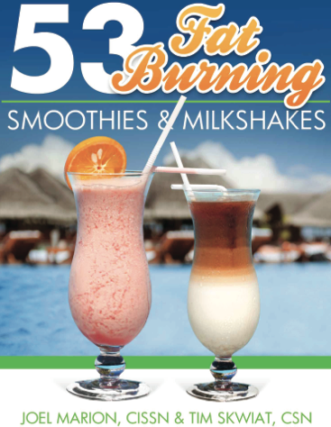

<http://challengeworkouts.com/wp-content/uploads/2014/03/53-fat-burning-smoothie-graphic.png>

Don’t make ‘on the run’ diet mistakes, choose from one of these delicious smoothie recipes, yours when you grab the **21 Day Challenge Diet**.

Sign off

[AFFILIATE.1ruckus.hop.clickbank.net/?id=cdiet](http://AFFILIATE.1ruckus.hop.clickbank.net/?id=cdiet" \t "_blank)

**Email 5 Fri Mar 7 am**

**Subject**: Don’t fall for this [SCAM]

I hate all the media hype over some ‘new’ diet craze that will have you drop 20 pounds over night.

It’s all B.S. (excuse my French).

Seriously, you’re too smart for that bunk.

The truth is, there’s NOTHING new under the sun that will have you magically beach-ready overnight.

BUT, there is something that I’d say is as close to magic as you’re gonna get where bikini-ready is concerned.

It’s called the ’21 Day Challenge Diet’ and I know for a fact that it’s magic because it’s worked for my good friend, Shawna K.

Take a look at here:



<http://challengeworkouts.com/wp-content/uploads/2014/02/fitnessshot-1.jpg>

She’s about to turn 51, she has visible abs and she eats pretty much whatever she wants. She follows a LIVEABLE nutrition plan and so many folks have nagged her about what her secrets are that she put it together in ‘**The 21 Day Challenge Diet’** plan for you.

She wants you to know that any false promise to drop tons of weight in a short time is a short lived promise to your fat loss goals and a long term way to mess up your metabolism forever.

Her plan is really the ‘non-diet diet’ where you’ll learn to change your eating habits and lifestyle to get into the BEST SHAPE ever. Here’s what Bruce had to say:



<http://challengeworkouts.com/wp-content/uploads/2014/02/bruce-h-email-testi.png>

The plan is for 21 days where you’ll drop up to 14 lbs - NOT an astronomical promise, but a practical one. This is followed by a 21 day ‘maintenance plan’ that had beta testers continue to drop pounds and inches while eating MORE food.

The BEST NEWS is that beta testers admitted that they were shocked at the results that came easily, like Marci:

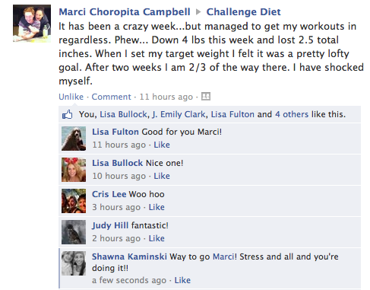

<http://challengeworkouts.com/wp-content/uploads/2014/02/ch-diet-fb-18-results.png>

If you follow her plan, **you’ll lose up to 14 lbs in 3 weeks** of sensible eating.

She also adds the ‘challenge’ of home workouts, but she, and the whole ‘Challenge Diet’ community hold your hand the whole way.

Smarten up where your diet is concerned, stop falling for dumb ideas and empty promises. Let Shawna and her 21 Day Challenge Diet community help YOU meet your fat loss goals.

**Lose up to 14 pounds in 21 days here**

Sign off

[AFFILIATE.1ruckus.hop.clickbank.net/?id=cdiet](http://AFFILIATE.1ruckus.hop.clickbank.net/?id=cdiet" \t "_blank)

**Email 6 (pm) Fri Mar 7 pm**

**Subject**: Eating out? Don’t blow it (here’s help)

This photo is going around the internet <= This once got me a 40% open rate ☺

Eating out is a fact of life.

It’s also a fast track to needing to buy bigger pants if you’re not careful.

My friend, Shawna K, has you covered where restaurant eating is concerned. You’ve probably seen pictures of her on the internet:



<http://challengeworkouts.com/wp-content/uploads/2013/12/shawna.jpg>

She’s almost 51 and looks like this year round. She travels a LOT and knows how to navigate a menu.

She has a BONUS for you:

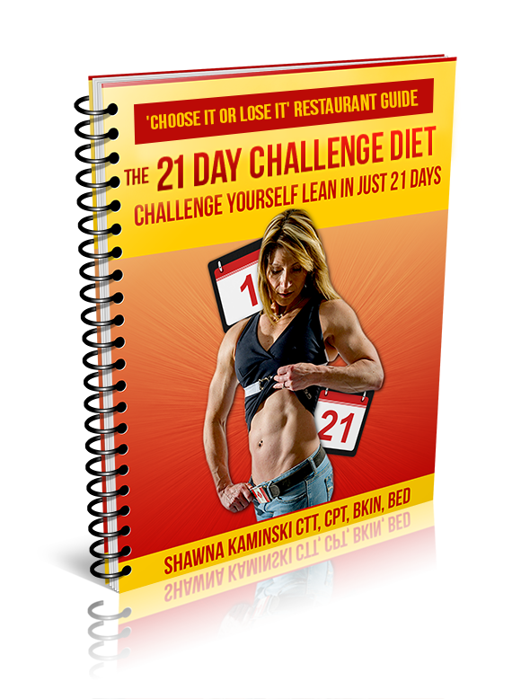

<http://challengeworkouts.com/wp-content/uploads/2014/02/restaurant-guide.png>

When you grab her ’21 Day Challenge Diet’ she wants you to have this ‘Choose It and Lose It’ restaurant guide so you know what to eat on the go.

It’s all part of her ’21 Day Challenge Diet’ plan that will have you dropping up to 14 pounds sensibly in 21 days.

Her beta test group participants got fantastic results in a short time, take a look at Cris and Katherine: (enable images)

**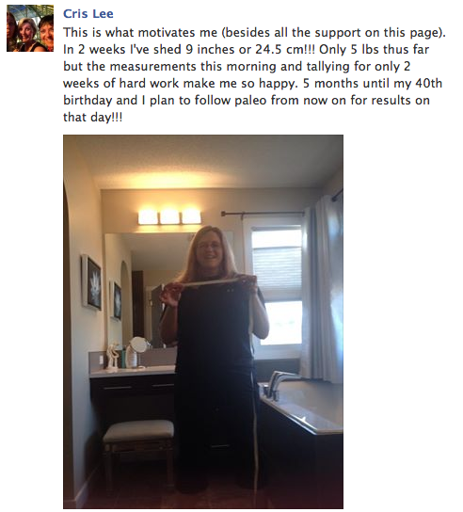**

[**http://challengeworkouts.com/wp-content/uploads/2014/02/ch-diet-fb-17-results.png**](http://challengeworkouts.com/wp-content/uploads/2014/02/ch-diet-fb-17-results.png)

****

<http://challengeworkouts.com/wp-content/uploads/2014/02/ch-diet-fb-21-keeper.png>

Grab her ’21 Day Challenge Diet today and get the BONUS ‘Choose It and Lose It’ restaurant guide too.

The only ‘challenge’ with her 21 Day Challenge Diet plan may be having to buy new clothes to fit with all the inches you’ll lose in such a short time.

**Get the best 21-day plan EVER**

Sign off

[AFFILIATE.1ruckus.hop.clickbank.net/?id=cdiet](http://AFFILIATE.1ruckus.hop.clickbank.net/?id=cdiet" \t "_blank)

**Email 7 Sat Mar 8 am**

**Subject**: Don’t go on a diet [against experts’ advice]

There’s no reason for you to start another diet.

Got that? Do NOT go on a diet.

Instead, take 21 days to change your lifestyle. Include healthy nutrition and add some challenging workouts. That’s what will transform your body. The good news is that studies show that it only takes 21 days to form a habit.

Lifestyle changes that include sensible nutritional changes will have you feeling so good about yourself that you won’t want to stop.

Here are 10 reasons why you should NEVER go on a diet. Make sure to ‘enable pictures’ so you can see the real time comments from ‘beta testers’ of the 21 Day Challenge Diet:

1. **The 21-Day Challenge Diet** is really the ‘non-diet diet’. You’ll make ‘livable’ nutritional changes that won't leave you hungry and deprived.



<http://challengeworkouts.com/wp-content/uploads/2014/02/ch-diet-fb-18-results.png>

1. You’ll eat REAL food, including all your favorites, so you’ll never feel like you’re dieting.

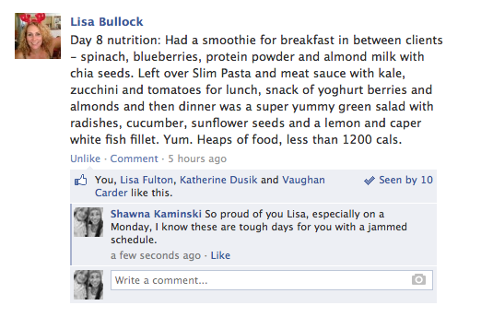

<http://challengeworkouts.com/wp-content/uploads/2014/02/ch-diet-fb-14-prog-rpt.png>

1. You’ll have ‘done for you’ meal plans and recipes to get you started, but the key ingredient is the education you’ll get with the plan.

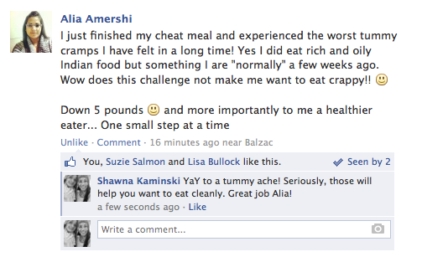

<http://challengeworkouts.com/wp-content/uploads/2014/02/ch-diet-fb-12-7-day-prog-report.png>



<http://challengeworkouts.com/wp-content/uploads/2014/02/ch-diet-fb-21-keeper.png>

1. In less than 21 days, you’ll know exactly what to eat to help you look and feel your best.

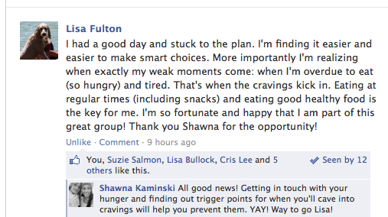

<http://challengeworkouts.com/wp-content/uploads/2014/02/ch-diet-fb-15-learning-to-eat-better.png>

1. You won’t go it alone. You’ll get the social support of a whole community of like-minded people that are going through the process with you.

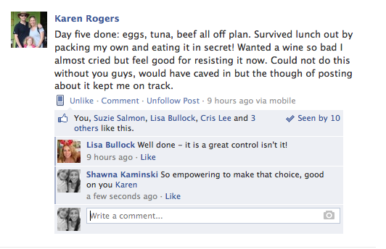

<http://challengeworkouts.com/wp-content/uploads/2014/02/ch-diet-fb-6-community-support.png>

1. You won’t gain an ounce back after 21 days since you’ll get a ‘done for you’ 21 day plan to follow up with.

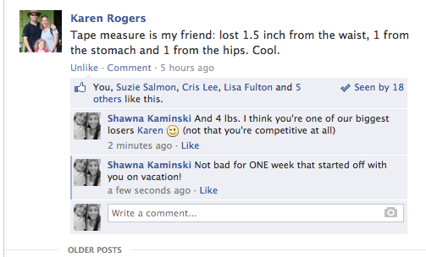

<http://challengeworkouts.com/wp-content/uploads/2014/02/ch-diet-fb-9-inches-lost.png>

1. You won’t be ‘sold a magic bullet’ but you’ll get REALISTIC home workouts that are really the ‘secret sauce’ to the plan.

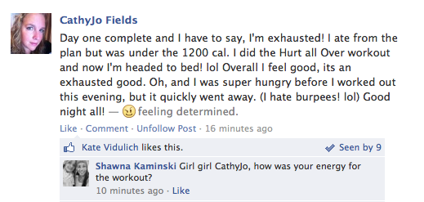

<http://challengeworkouts.com/wp-content/uploads/2014/02/ch-diet-fb-comment-1.png>

1. You’ll be challenged you at YOUR fitness level and be held accountable by the group to follow both the nutritional and physical challenges.
2. You’ll be able to eat out and know exactly what to eat to support your goals.

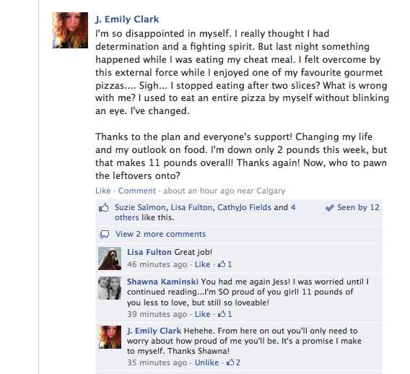

<http://challengeworkouts.com/wp-content/uploads/2014/02/ch-diet-fb-16-long-term-changes.png>

1. Best of all, you’ll NEVER go on a diet again as you’ll reach your fat loss goals sensibly and painlessly.



<http://challengeworkouts.com/wp-content/uploads/2014/02/ch-diet-fb-22-use-this.png>

Don’t go on a diet ever again, but consider ‘The 21 Day Challenge Diet’ to change your eating habits and lifestyle.

You’ll be pleasantly surprised at how easy it is and the results that come quickly.

**Get started here and join the exclusive community**

Sign off

[AFFILIATE.1ruckus.hop.clickbank.net/?id=cdiet](http://AFFILIATE.1ruckus.hop.clickbank.net/?id=cdiet" \t "_blank)

**Email 8 Sat Mar 8 pm**

**Subject**: Probably not for you anyway [sorry]

Unless you’re living under a rock, you’ve probably heard about the ’21 Day Challenge Diet’ (that’s not really a challenging diet) that all the big names in online fitness are talking about this week.

If you haven’t jumped on board by now, maybe you’re just not interested in learning how to get and stay lean effortlessly.

Well, that’s a bit of a lie. There’s effort involved, but according to the beta testers of the plan, it seems effortless compared to the many other stupid ‘diets’ that they’ve tried.

This is really the ‘non-diet diet’ in that the plan really just teaches you healthy nutritional eating. Along with it, you’ll get easy to follow fitness challenges that take about 20 minutes a day. You’ll get treat meals along the way and a ton of social support from the ‘Challenge Diet’ secret group as you get steady lasting results.

If you want to be part of this ‘non-diet diet’ movement, you can still **jump on board tonight.**

BUT, there’s limited space in the ‘secret’ group though and membership will close down at midnight tonight.

The social support of the 21 Day Challenge Diet is a big part of the magic of this plan. Few other nutritional plans offer this sort of hand-holding. In fact, there are people from all over the world in this secret group so you’ll find 24/7 support there.

Don’t miss out on the opportunity to start the 21 Day Challenge Diet and never go on a diet again. Here are a few comments after 21 days:

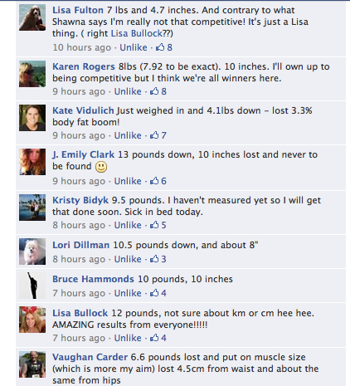

<http://challengeworkouts.com/wp-content/uploads/2014/02/ch-diet-final-2.png>

**Check it out here.**

**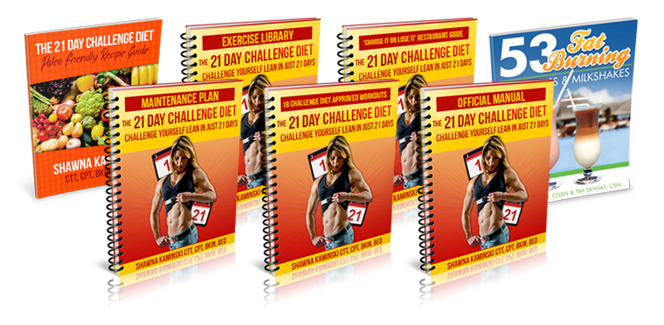**

[**http://challengeworkouts.com/wp-content/uploads/2014/02/ch-diet-main-product-bundle.jpg**](http://challengeworkouts.com/wp-content/uploads/2014/02/ch-diet-main-product-bundle.jpg)

Sign off