**Challenge Jump Rope Benefits**



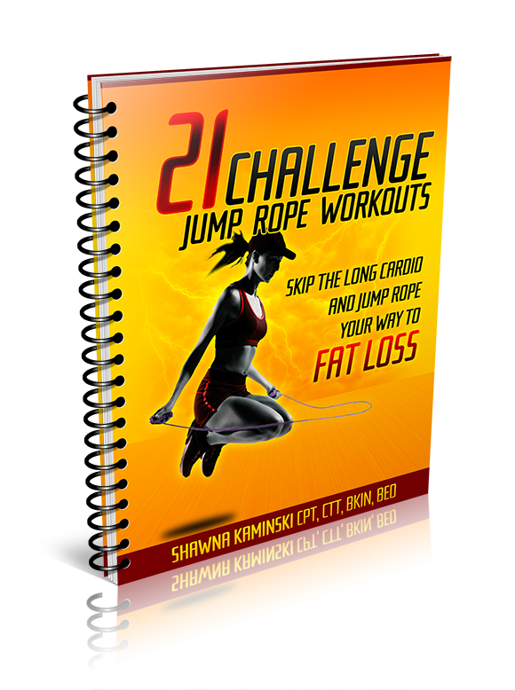**Challenge Jump Rope Workouts**

-Use the most inexpensive training tool ever

-21 jump rope workouts that are 6-15 minutes in length

-Increase your metabolism without doing boring traditional cardio ever again

-Use the jump rope in the perfect combination with other exercises to avoid an increase in the fat storing hormone, cortisol

-Can be used on your ‘day off’ from training to boost metabolism

-Use ‘anaerobic’ training to decrease your body fat, increase your over all fitness and aerobic capacity

-A great addition to ANY program

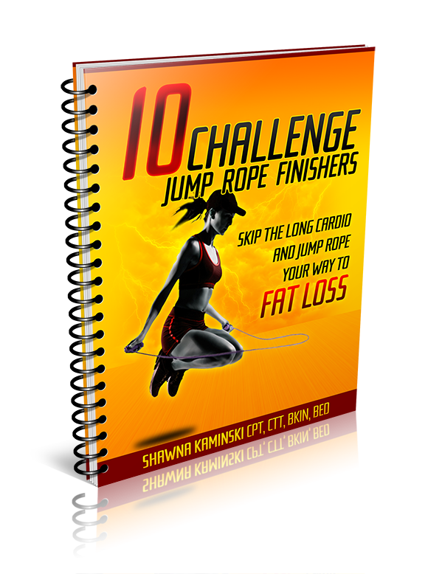**Challenge Jump Rope Finishers**

-These workouts are meant to be used as a ‘finisher’ or on your day off

-Find 10 MORE fun and challenging mini workouts

-Alleviates workout boredom by providing more variety with your finishers

-Can be done anywhere with just your bodyweight and a jump rope

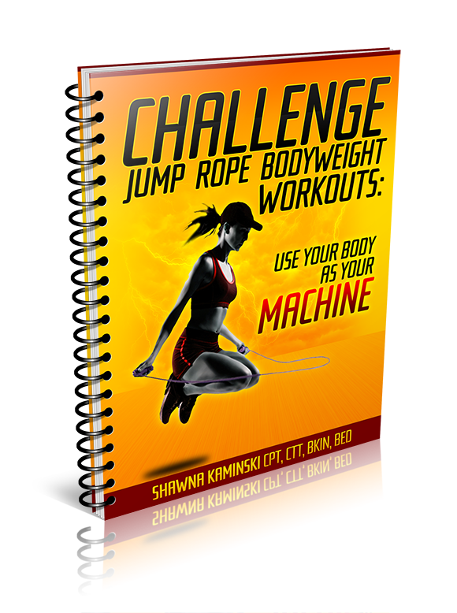**Challenge Jump Rope Bodyweight Workouts**

-Who doesn’t want MORE bodyweight workouts that you can use anywhere at anytime with just your bodyweight?

-Get a 4 week bodyweight plan that you can use to increase strength and muscle tone, add a jump rope finisher and you’re all set!

**Coaching Videos**

-Video tutorials walk you through each workout

-Exercise form tips from a master certified trainer

-Learn ways to intensify or modify each exercise

-Learn the common errors and what to look out for to avoid injury.

-Get a sense of the intensity and fun each workout can be by watching the 3-5 min video before executing the workout yourself

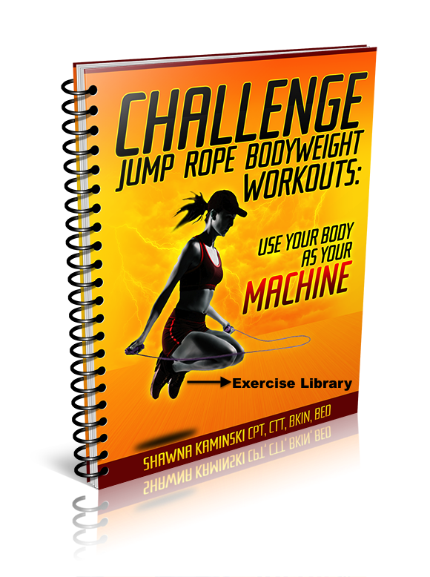**Challenge Jump Rope Exercise Library**

-Ensure that you’re doing every exercise properly by referring to this alphabetized library with descriptions and pictures of each and every exercise

**The Jumbo Jump Rope Guide**

-A guide with 63+ descriptions and video demonstrations of jump rope steps

-Increase exercise variety so you'll never be bored with jump rope workouts

-Increase balance and coordination that will transfer to other areas of life

-Increase mental awareness and concentration

-Find super fun challenges to do to impress your friends and the 8 year olds on the playground too ;)

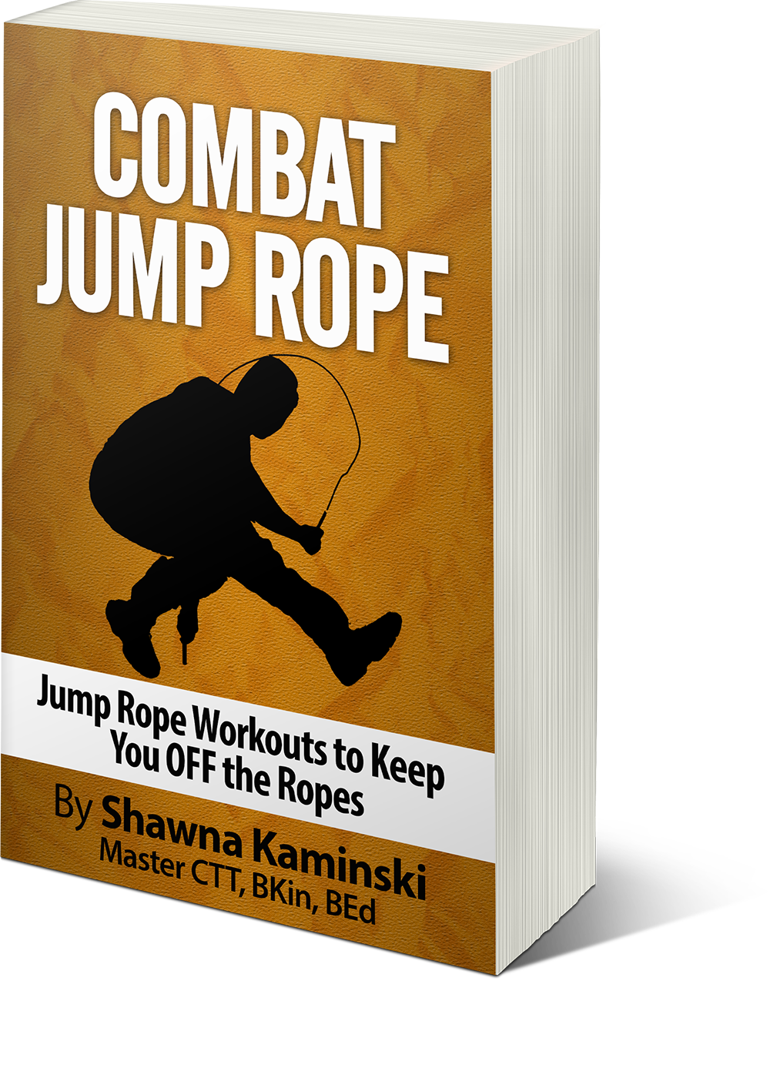**Combat Jump Rope**

-Look and train like a fighter even if you never get into the ring

-Enjoy 10 MORE bodyweight workouts that are under 20 minutes

-Workouts can be done anywhere, any time with little space and with just a jump rope

-Get even MORE fun and challenging workouts incorporating the jump rope.