**Challenge Burpee Benefits**



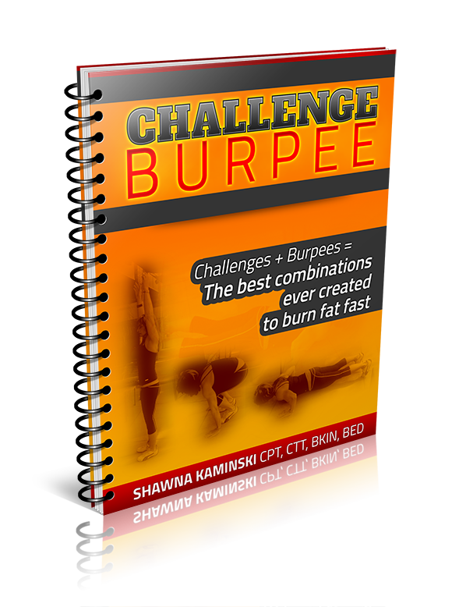**Challenge Burpee Workouts**

-Get 21 Challenge Burpee workouts that use bodyweight and light DB’s to work the entire body in less than 20 minutes

-Ideal for an ‘off day’ full body metabolic boost, these can be also used as a stand alone program

-Great full body workouts for small spaces and limited workout time

-Increase your metabolism without doing boring traditional cardio ever again

-Use burpees in the perfect combination with other exercises to avoid an increase in the fat storing hormone, cortisol

-Use ‘anaerobic’ training to decrease your body fat increase your over all fitness and aerobic capacity

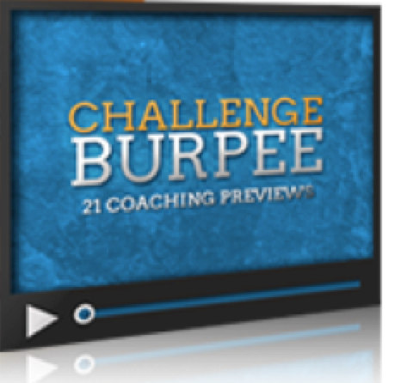**Challenge Burpee Coaching Videos**

-Video tutorials walk you through each workout

-Exercise form tips from a master certified trainer

-Learn ways to intensify or modify each exercise

-Learn the common errors and what to look out for to avoid injury.

-Get a sense of the intensity and fun each workout can be by watching the 3-5 min video before executing the workout yourself

**Challenge Burpee Exercise Library**

-Ensure that you’re doing every exercise properly by referring to this alphabetized library with descriptions and pictures of each and every exercise

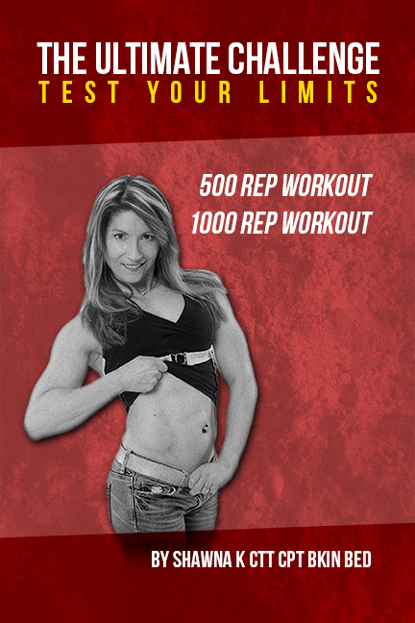**The Ultimate Challenge**

-Get 500 & 100 Rep Burpee workouts

-Test your limits with these extreme burpee workouts

-Use these workouts as ‘bench marks’ to compare your fitness progress

-Take burpees to a whole new level, along with your fitness

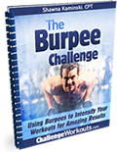**The Burpee Challenge**

-Use advanced burpees and burpee pull up combinations along with metabolic resistance training to sky rocket your fitness and fat loss.

-Get 16 ADDITIONAL burpee challenges

-Use these workouts as ‘benchmarks’ to access fitness progress

**The Big Book of Beautiful Burpees**

-Add even more variety to your workout by swapping in any of the 77+ burpee variations that you’ll find in this guide

-Read the written descriptions or view the video demonstrations of each burpee variation to learn how to do more burpees than you could ever imagine

-Never do the same workout twice by swapping in a different burpee variation – you’ll have countless burpee workouts at your fingertips

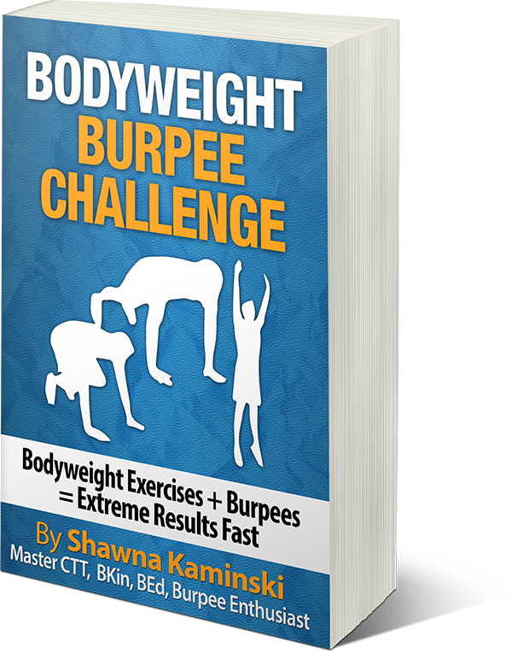**Bodyweight Burpee Challenge**

- Enjoy 10 MORE bodyweight burpee workouts that are under 20 minutes

-Workouts can be done anywhere, any time with little space and with your bodyweight and the beautiful burpee

-Get even MORE fun and challenging workouts incorporating the jump rope.