**Challenge Complexes Benefits Page**

You can find swipes, images, videos and a rebrandable report here: <http://challengeworkouts.com/complexes-swipe-emails>

Main sales page: [www.ChallengeComplexes.com](http://www.ChallengeComplexes.com)

Price: $19 for re-launch ($29 regularly)

Here’s a benefit rich summary of the entire program and upsells so that you can position it well with your readers.

Take a look at Challenge Complexes for BB, DB and KB complexes that you can use to burn fat, boost metabolism and BUILD muscle in workouts that are 20 minutes or less.

**Here’s what you’ll get:**

**17 Barbell complexes**

* use a single barbell to Boost Metabolism, Build Muscle and Burn Fat
* learn the most effective lifts to safely get an intense workout in 20 min or less
* use BASIC and simple barbell moves to achieve your strength and fat loss goals
* replace HIIT with amazing strength building workouts
* perfect lifting technique while burning fat
* avoid getting ‘skinny fat’ by maintaining and adding sexy, lean muscle tone
* maintain and improve your strength by incorporating challenge complexes
* use as a stand alone workout or incorporate into your program as ‘cardio’ or on your day off

**10 Dumbbell complexes**

* add even MORE variety by using a single set of dumb bells to boost your metabolism, build muscle and burn away fat
* avoid useless and boring gym machines by using only ONE set of dumb bells and a small space
* train ANYWHERE for 20 minutes or less and achieve your fitness goals

**Bonus: 8 KB complexes from Chris Lopez**

* use simple and basic kettle bell moves in easy to follow complexes from a KB master
* perfect your KB moves while replacing boring cardio
* All these come with coaching videos so you’ll know just what to do.

Shake up YOUR training, stay safe, build muscle, boost metabolism and burn fat all in less than 20 minutes.

Last year’s results on upsells:

In December 2013, here are the conversions on upsells:

upsell 1 - 25%

upsell 2 - 18%

upsell 3 - 18% (changed this to Challenge Diet this year)

**Upsell #1 – Challenge Complexes – Ab Edition $14**

<http://challengeworkouts.com/complexes-up-1>

• Use the video coaching previews so you’ll know exactly how to do each and every fat-burning rep with precision.

• Use exercises you’ve never thought of before to blast your core.

• Get the ‘secret sauce’ to the sequencing of exercises, timing, reps and workout formats.

• Get ‘never done before’ workouts to add variety, reduce boredom and increase intensity to help you reach your fitness goals.

**Special bonus:** Get my 15 MORE Ab Challenges – New Ways to Get Old School Abs (with exercise library and video library to ensure your form is impeccable.

**Plus additional bonus,** you’ll get 4 weeks of bodyweight complexes.

## Upsell #2 - Challenge complexes: Olympic Edition $9

## <http://challengeworkouts.com/complexes-up-2>

Discover the BEST way to introduce Olympic style lifts into complexes to keep you safe while building strength and burning fat even faster with these 15 Olympic Style Complex Workouts.

You’ll discover exactly what lifts to include giving you the best bang for your buck and staying injury-free.

**Bonus -** Plus, with this insider access, you’ll also discover how to keep your shoulders strong and flexible with this **Shoulder Strengthening and Mobility Report**

**Upsell #3 Challenge Diet $14**

<http://challengeworkouts.com/complexes-up-3>

A 21-Day (follow along) Rapid Fat loss Diet That Really Works - Give Yourself Just 21 Days and You’ll Discover How to Lose Up to 14 Pounds of Fat and Keep it off for good.

* 21 day step by step meal plan
* 21 day done for you maintenance plan
* 40+ paleo style delicious recipes
* food template
* social support and daily motivation in private group
* 18 additional bodyweight workouts
* 53 smoothie recipes
* ‘Choose It and Lose It’ Restaurant Guide

**Affiliate Goodies**

**Go the affiliate center here where you’ll find swipes, videos, images, a rebrandable report and more:**

<http://challengeworkouts.com/complexes-swipe-emails>

Below are the high converting emails used for the launch. Feel free to use them as you see fit.

Email #1 Day 1 am mailing

Your affiliate link:

[AFFILIATE.1ruckus.hop.clickbank.net/?id=complexes](http://affiliate.1ruckus.hop.clickbank.net/?id=complexes)

**Subject line options:**

The ultimate cardio replacement

This is better than intervals (intense)

**Body:**

I hate cardio.

Don't we all?

Well, sadly, no. When I go into my gym I still see row upon row of cardio machines jammed with magazine readers hoping to lighten the load of their belly fat. But it won't happen.

Did you know that traditional cardio increases your cortisol production and can lead to muscle and strength loss?

Also a recent study at the University of Tampa showed that adding ‘Jogging’ to a weight training program decreased strength gains by 50%.  
  
If you're getting weaker you're losing muscle. And if you're losing muscle, your fat percentage is going up.  
  
I don't know about you, but I'd rather be stronger and leaner than weaker and fatter.

Yet another reason NOT to do traditional cardio.

**Here’s the ultimate cardio replacement**

Sure, we all know about HIIT, but let’s face it, you can get too much of a good thing. If you notice that you’re feeling your performance is lacking, you’re getting weaker, losing muscle and generally just looking ‘soft’, it may be time to put HIIT on vacation.

**This is better than intervals (intense)**

One that will burn fat, boost metabolism and build muscle in 20 minutes or less?

If you want to look like (and feel like) a super hero, build your strength and coordination, and make everyday activities so much easier…

… just use this approach for 20 minutes or less.

This approach (once only used with athletes) will strip off body fat and build rock solid muscles at the same time because of the metabolic and progressive approach.

Shake up your program with something completely different.

**Put ‘cardio’ and ‘HIIT’ on the shelf and try this.**

Sign off

Email #2 Day 1 pm mailing

Your affiliate link:

[AFFILIATE.1ruckus.hop.clickbank.net/?id=complexes](http://affiliate.1ruckus.hop.clickbank.net/?id=complexes)

**Subject line options:**

**The perfect “anti-aging” workout design**

**20-minute workouts PROVEN to reverse aging inside**

**Horrible advice from a young trainer**

Age is NO excuse for belly fat!

My good friend and super hot trainer (who’s also the OLDEST hard body I know) says: *‘Age is only a number and NEVER an excuse for excessive belly fat or being inactive. I hope your belly fat is listening here.’*

It should be easier to take advice from someone who’s a little older that’s walking the walk.

**Check out some of her secrets here.**

It’s easier to dismiss advice when it comes from a trainer in their 20’s, one that hasn’t bore children, changed careers, had life experiences or otherwise been on the planet for more than a few decades. When you hear this from someone who isn’t a spring chicken, then your belly fat should be getting a little nervous.

Shawna has proven that there are multiple ways to maintain super high intensity workouts to get rid of YOUR belly fat while respecting your body. It’s not wise to go crazy on stupid training protocols *whatever your age*. You need to increase intensity to workouts slowly in a progressive manner that helps you avoid an injury disaster.

You’ll get the results you're after without the aging aches and pains you may think you’ll get with her intense workouts.

Take a page from Shawna K’s book, which by the way as visible abs year round without crazy dieting or training all day long. She has this for you:

**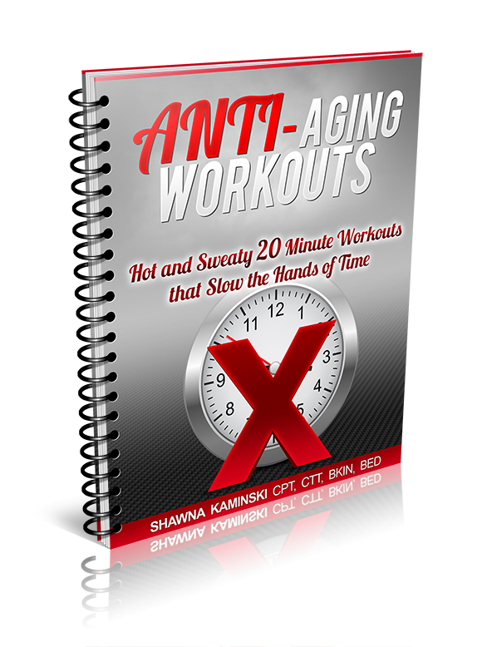**

[**http://challengeworkouts.com/wp-content/uploads/2013/12/antiagingworkouts-1.png**](http://challengeworkouts.com/wp-content/uploads/2013/12/antiagingworkouts-1.png)

Here’s a month of fun home workouts for you to use to kick your belly fat to the curb. You’ll need about 20 minutes with very little equipment and space.

You’ll get this FREE when you grab her **Challenge Complexes**.

**Challenge Complexes** is a new program just released that uses minimum equipment to burn fat, boost metabolism AND build muscle in workouts that are 20 minutes or less.

Honestly, Shawna is one of the MOST respected trainers out there. She recently was the fitness expert on Spike TV’s Gym Rescue, her body speaks for itself; she clearly knows a thing or ten about training.

🡺**Grab Anti-Aging here before midnight tonight**

sign off

Email #3 Day 2 am mailing

Your affiliate link:

[AFFILIATE.1ruckus.hop.clickbank.net/?id=complexes](http://affiliate.1ruckus.hop.clickbank.net/?id=complexes)

**Subject line options:**

**The best 20-minute complex you’ll EVER do**

**NEW complex (how to burn fat and build muscle at the same time)**

**Body:**

Of course you know that muscle is key to the fat burning process. Muscle is more ‘dense’ than fat meaning that it takes up less space in your jeans. Your body weight may drop or even stay the same weight, but your shape will drastically change.

And change is what it’s all about. Who cares what the scale says if you’re looking better naked and not ashamed to lift up your shirt and show off your abs?

**These complexes take about 20 minutes <= Best complexes EVER**

Lots of people are STILL using cardio to try to get their abs to show. Whether you’re doing low intensity cardio like running on a treadmill or even doing HIIT (high intensity intervals) you may be getting to a point where results are just not happening.

Are you strength training as well as doing cardio? If your workouts are too long you can run into overtraining PLUS encourage cortisol, **which is the hormone that promotes fat storage.**

**This is the ultimate “hybrid” of cardio and strength**

How about a scientific workout that manipulates your fat burning hormones?

Complexes involve incomplete workout recovery for lactic acid and GH production. This is paired with strength training moves that will build lean muscle, boost your fat burning hormones and reduce your fat storing hormones – in about 20 minutes. Bonus: More lean muscle means an increased resting metabolic rate to burn more calories even at rest.

It can be done… when structured right…

My good friend, Shawna Kaminski has a really unique and simple to follow plan for you using the power of complexes (the same type of training the hot celebrities use for their movie roles).

**Take a look at it here**

You’ll find cool workouts like this one below that she allowed me to share:

**Workout 2 Six by Six (Reps and rounds)**  
Choose a weight that you can use for ALL exercises. Try not to put the bar down throughout the set. Rest up to one minute between sets.

6 reps of each:

* Bent over row
* RDL
* High pull
* Front squat
* Push press
* Burpee with push up

Rest 30 sec to 1 minute

4 to 6 rounds

Optional: use Video workout image with the words: See the workout here. If you do this, add a link to your blog and add the workout and video with affiliate links there.

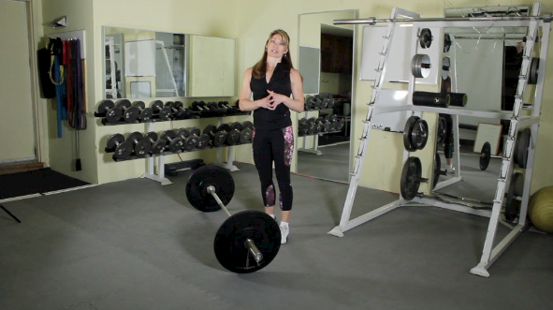

<http://challengeworkouts.com/wp-content/uploads/2013/12/ch-complex-video-graphic.png> (image)

Here’s the video: <http://youtu.be/XlvlTc4syCo>

Even though Shawna is 51 years old, she’s literally the oldest hard body I know, she looks and performs like a woman easily 20 years younger. Her secrets WORK, her plans WORK.

You’ll get expert coaching every step of the way since each workout comes with a coaching video so you’ll know exactly what to do.

**Discover how ‘complexes’ will change your body here**

SIGN OFF

* **Get Challenge Complexes here. Don’t let the holiday season or lack of time be an excuse for adding to your belly fat.**

Email #4 Day 2 pm mailing

Your affiliate link:

[AFFILIATE.1ruckus.hop.clickbank.net/?id=complexes](http://affiliate.1ruckus.hop.clickbank.net/?id=complexes)

**SEND SAME EMAIL TO UNOPENS**

Email #5 Day 3 am mailing

Your affiliate link:

AFFILIATE.1ruckus.hop.clickbank.net/?id=complexes

**Subject line options:**

Get abs BEFORE New Year’s

Bored with cardio? Here’s a more effective way to burn fat

**Body:**

Cardio doesn’t work… there’s a more effective way to burn fat, I’ll show you how.

Today I want to give you a chance to get your hands on the EXACT program you need to get your body in BETTER condition BEFORE the New Year even starts.   
  
This guide will provide the *perfect* workouts to use so you can hit the sweet spot of fat-loss even before the holidays begin... all while building lean, defined muscle.

Look, you may already be feeling holiday stress, you don’t need to add to it by having long workouts or worse yet, NO workouts because you ‘*don’t have time’*.

With stress (even the stress from a long workout), your adrenal glands pump out cortisol, the fat storing hormone. You need a plan for quick and effective workouts.

=>**Get the best complexes EVER here**  
Here’s exactly how it works.   
  
When you use Shawna’s 20-minute complexes, you’ll automatically "shift" your hormones into *fat-burning* mode WITHOUT stressing out your adrenal glands which release fat-storing cortisol with long workouts.  
  
...And it has nothing to do with just shortening your workouts.   
  
Inside this system you’ll discover a new and different way to train that will:

-replace boring cardio

-improve your athleticism

-build muscle

-boost metabolism

-burn fat  
  
This extreme fat-burning method strategically "spares" hormones, like growth hormone, by using a specific combination of strength training and *"just enough"* high intensity exercise to hit the SWEET SPOT of fat-burning.   
  
==> 20 minute EXTREME fat-burning breakthrough <------ do NOT click yet   
  
Now, you do these simple to follow workouts right in the comfort of your own home. You’ll get coaching videos to guide you through each workout.  
  
*- NO need to spend time in holiday traffic.*   
  
*- NO need for fancy equipment: just a barbell, a set of dumb bells and a KB.*  
  
*- NO excuses.*   
  
Just get your workout done in 20 minutes or less.   
  
You’ll love how you look and feel at the start of the New Year when everyone else is 8 – 13 lbs heavier.   
  
So do yourself a big favor.   
  
**Grab Challenge Complexes** and get abs for Christmas in just 20 minutes a day.   
  
==> **Grab Challenge Complexes here**

***The way I see it you basically have two choices...***   
  
**CHOICE #1:** Wait until after New Year’s, get fatter, regret you didn’t take   
action sooner, and try your best to get in great shape AFTER the holidays.   
  
**OR...**   
  
**CHOICE #2:** Start using *Shawna’s Challenge Complexes* today and take advantage of the PERFECT plan and strategy to guarantee you’ll be looking and feeling great by New Year’s and beyond.  
  
Hmmmm...seems like an OBVIOUS choice to me :-)   
  
Get the entire system and thank me later:   
  
==> Start getting your body ready for the New Year NOW  
  
Remember...it’s either the pain of taking action RIGHT now, ***or*** the bigger pain of **regret** after the holidays.

Sign off

P.S. Cardio is boring. This works better and faster!

PPS. Shawna is KNOWN for her fitness expertise; in fact, she was on Spike TV’s ‘Gym Rescue’ this year as the fitness expert. She knows what works to get you the leanest and strongest in the least amount of time. Give THIS a try because she backs her programs up with a 60 day money back guarantee if you’re not happy.

Use this picture if you like:

http://challengeworkouts.com/wp-content/uploads/2014/08/gym-rescue-1.png

Email #6 Day 3 pm mailing

Your affiliate link:

[AFFILIATE.1ruckus.hop.clickbank.net/?id=complexes](http://affiliate.1ruckus.hop.clickbank.net/?id=complexes" \t "_blank)

**Subject line options:**

**Try this workout (result picture inside)**

**Hey, your workout for today (enclosed)**

**Body:**

Check out this picture below, she is in amazing shape… and she’s 51 years old!

Shawna asked me to share this workout program with you – it’s from her **Challenge Complexes** program.

You can check out the workout below, but first I wanted to tell you a bit about this style of workout because it’s unlike anything you’re doing now.

There’s a trick to putting together ‘complex’ workouts. Often times trainers try to make things challenging by putting together impossible exercise combinations. Shawna says that complex workouts really need to be simple in their design so as not to cause strain on certain muscle groups and to ensure you stay injury free.

That’s what I love about her workouts: safe, effective and fun. They’re full of variety and challenges but they aren’t ‘*impossible*’. Shawna is as experienced a trainer as they come. She’s in incredible shape at 51 and uses complexes in her training. Trust me, if I could look like her at 51, I’d be willing to do what she says now.

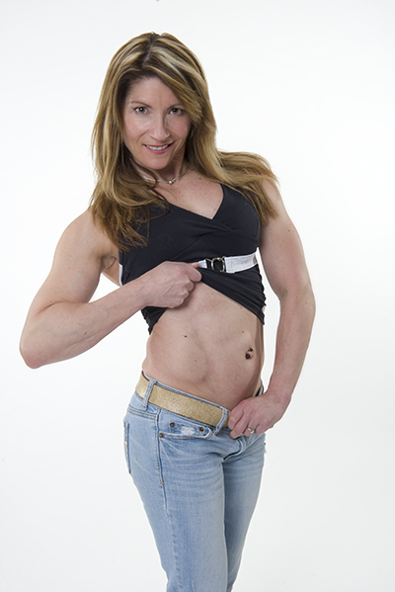

[http://challengeworkouts.com/wp-content/uploads/2013/12/Fitness008.jpg](http://challengeworkouts.com/wp-content/uploads/2013/12/Fitness008.jpg" \t "_blank)

Okay, here’s the workout:

**Let’s Get This Started (Reps and rounds)**  
Equipment: dumb bells

Choose a weight that you can use for ALL exercises.

Do 8 reps of each exercise. Try not to put the DB’s down the entire set, do 6 rounds. Time your workout, match the time with increased load the next time out:

•      DB push up (hands on dumb bells)

•      Spider crawl (per leg)

•      Weighted burpee (squat thrust to deadlift)

•      High pull

•      Front squat push press

•      Rest 30 seconds to one minute

Do 6 rounds

Have fun with that one and make sure to check out her plan.

**BTW get Challenge Complexes for just $19 this week.** That works out to about 70 cents a workout.

Sign off

Email #7 Day 4 am mailing

Your affiliate link:

[AFFILIATE.1ruckus.hop.clickbank.net/?id=complexes](http://affiliate.1ruckus.hop.clickbank.net/?id=complexes" \t "_blank)

**Subject line options:**

**Yes, those are HER abs, it’s not photo shopped (pic enclosed)**

**This photo is going around the web… FAST**



**[http://challengeworkouts.com/wp-content/uploads/2013/12/noexcuses-.jpg](http://challengeworkouts.com/wp-content/uploads/2013/12/noexcuses-.jpg" \t "_blank)**

Shawna Kaminski (the 50-year old in the photo above) uses her body as a testing ground for her workouts, (along with the thousands of clients she trains worldwide).

She’s redefining age and she’s living proof that you can be lean, athletic, and have killer abs at any age.

She is hands down the oldest hard body I know. Would you believe that Shawna is 50 by looking at the photo? Clearly she knows what she’s doing.

Here’s her secret training program

And she’s done it again. She’s come out with a new twist on an old training concept: it’s ‘complexes’ now.

If you think you know about complexes, think again, you’ll find new and different barbell and dumbbell combinations and you’ll even get some bonus kettlebell complexes in her plan.

Take a look at **Challenge Complexes** and you’ll find workouts like:

* Enough Already
* Rack It!
* Monkey on Your Back
* Challenge Limbo
* Never Quit
* I Dare Ya
* Make That a Combo
* Man Up!
* Meat and Potato Complex

Keeping your workouts full of fresh ideas will keep your results coming.

For LESS THAN ONE THIRD of the price of a session with a mediocre trainer, you can have a plan created by a trainer with international accolades and status, one that has a proven track record for getting results.

Grab **Challenge Complexes** before the price more than doubles at midnight tonight.

The good news is that if you find the plan isn’t right for you, you’ve got a 100% money back guarantee. But I’ll guarantee you this: if you give her plan the old college try, you’ll be more than pleasantly surprised.

Here’s what you’ll get:



[http://challengeworkouts.com/wp-content/uploads/2013/12/challenge-complex-graphic.png](http://challengeworkouts.com/wp-content/uploads/2013/12/challenge-complex-graphic.png" \t "_blank)

**17 BB complexes**

-use a single barbell to Boost Metabolism, Build Muscle and Burn Fat

-learn the most effective lifts to safely get an intense workout in 20 min or less

-use BASIC and simple barbell moves to achieve your strength and fat loss goals

-replace HIIT with amazing strength building workouts

-perfect lifting technique while burning fat

-avoid getting ‘skinny fat’ by maintaining and adding sexy, lean muscle tone

-maintain and improve your strength by incorporating challenge complexes

-use as a stand alone workout or incorporate into your program as ‘cardio’ or on your day off

**10 DB complexes**

-add even MORE variety by using a single set of dumb bells to boost your metabolism, build muscle and burn away fat

-avoid useless and boring gym machines by using only ONE set of dumb bells and a small space

-train ANYWHERE for 20 minutes or less and achieve your fitness goals

PLUS… you’ll get a bonus training program that’s going to blow you away. Take a look at it here.

SIGN OFF

PS. The sale is DONE at midnight tonight and then the price doubles, so check out **Challenge Complexes here** and pick it up before midnight.

Your affiliate link:

[AFFILIATE.1ruckus.hop.clickbank.net/?id=complexes](http://affiliate.1ruckus.hop.clickbank.net/?id=complexes" \t "_blank)

Email #8 Day 4 pm mailing

**Subject Line**

**TIME SENSITIVE MESSAGE (read before midnight)**

You and I are different than everyone else.

Even during the holidays we keep focused on our workouts, nutrition, and training.

For us, there’s no point in waiting for the New Year before committing to workout. I’d rather keep the weight off now and go into the New Year looking and feeling my best!

And that’s why I wanted to make sure you got this email before midnight tonight, because when the clock strikes 12 my friend Shawna Kaminski is going to double the price of her Challenge Complex Program.

People always ask me if complex workouts work.

I always tell them that if a 51 year old woman can look so hot, fit, and athletic as this picture of Shawna then you know complex workouts work!

But like I said, time is ticking and at midnight tonight the 50% off sale for Challenge Complex goes away so be sure to pick it up while it’s still on sale.

**Click Here To Check Out Challenge Complex**

Talk soon,

<Sign off >

**\*hyperlink all underlined text ;)**

Following are two great emails from Shaun. PLEASE CHANGE THESE UP, DON’T COPY WORD FOR WORD BUT USE THE GENERAL IDEAS:

Shaun Hadsell’s best converting email:

# Subject: Ready for something COMPLETELY different?

A 1998 study in the *International Journal of Sports*   
*Nutrition* had a group of participants do 45 minutes   
of cardio per day, 5 days per week.   
  
They followed this protocol for 3 months.   
  
**Get this**: They lost NO more weight than those who   
dieted alone.   
  
Talk about a big waste of time.   
  
And how about this 2007 study in the *Journal of Obesity*,   
which revealed that doing 60 minutes of cardio, 6 days   
per week, only resulted in an average of 3.5 pounds of   
total weight loss after an entire year.   
  
***Yikes***.   
  
That adds up to 312 hours of cardio in a single year.   
  
So unless you’re doing steady state cardio in a very limited   
and strategic way, it’s a total waste of time.   
  
Now of course, you know I recommend intervals and weight   
training instead, which is obviously better than your standard   
cardio...   
  
...But it can be very time consuming *and* confusing to many   
folks because of the endless options and information overload.    
  
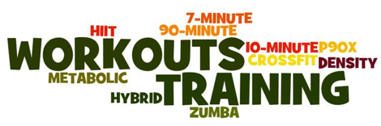  
  
So are you ready for something COMPLETELY DIFFERENT?   
  
**Consider COMPLEXES**.   
  
They can be used...   
  
**==>** **As a replacement for boring cardio**   
  
**==>** **As a conditioning tool for sports, races, or events**   
  
**==>** **As an off-day "Bonus" workout**   
  
**==>** **Or added to ANY workout you're currently doing**   
  
Complexes are SIMPLE: take one barbell (or a set of dumbbells   
or even a kettlebell) move it around without ever putting it down   
and you’ll work your ENTIRE body.   
  
***Done***.   
  
And they’re an awesome way to shatter plateaus as well.   
My great friend, Shawna Kaminski (<-- 51 year old ripped female   
freak) released her brand new program called, ***Challenge***   
***Complexes*** and she’s offering a special deal to celebrate.   
  
You can learn all about it HERE.   
  
If you’re bored of the same ole’ same ole’ and looking to try   
something new...or you’re stuck, THIS will help.   
  
Keep going strong,   
  
Shaun

Shaun Hadsell’s last pm email

Earlier this week I sent you an email about something   
COMPLETELY different that you’ve probably never   
tried before – and it can help you *destroy* body fat.   
  
It uses the same type of philosophies as group training   
sessions, like Crossfit and Insanity...   
  
...But with a few very important differences.   
  
In fact, most people using this style of training can lose   
up to 2% body fat a week.   
  
*That’s the good news.*The **bad news**...however, is the injury risk is so high most   
folks NEVER see their end goal because they end up having   
to stay at home due to some kind of injury.   
  
That’s why I recommend you try "complexes" instead.   
  
They’re safer and take less than **half** the time.   
  
**But there are only 9 hours left before the price more**   
**than doubles:**ALL the benefits of Crossfit and Insanity in HALF the time **<--- UNDER 20 bones**You also get coaching videos from my great friend, Shawna   
Kaminski, who is an inspiration to thousands with her 50+ year   
old ripped body.   
  
**This way you’ll** know **you’re using correct form and proper**   
**programming.**Remember, Complexes can be used...   
  
**==> As a replacement for boring cardio**   
  
**==> As a conditioning tool for sports, races, or events**   
  
**==> As an off-day "bonus" workout**   
  
**==> Or they can be added to ANY workout you’re currently doing   
  
Complexes are simple:** take *one* barbell (or a set of dumbbells   
or even a kettlebell) move it around without ever putting it down   
and you’ll work your ENTIRE body.   
  
***Done.***- NO switching weights or finding a machine to set up.   
  
- NO waiting in line.   
  
- NO confusion about how to set up your exercises the right way.   
  
And they’re famous for helping people shatter plateaus as well.   
  
**Try something different - Burn Fat using Complexes.** **<--- UNDER 20 bucks**Keep going strong,   
  
Shaun

This email comes from John Rowley who used it as his last email on the last day (please change up):

Subject line: Don’t get banned from this

I’m not here to “bash” Crossfit, but the truth is that most of these group sessions use a variety of complexes that absolutely destroy fat. In fact, most people using this style of training can lose up to 2% body fat a week!

That’s the good news.

The bad news… the injury risk is so high, that most folks don’t get to see their end goal because they end up having to stay at home because of some kind of injury.

**These complexes are BETTER than Crossfit**<= **And much safer**

And you’ll get dozens of them for under $20…

… but this offer ends tonight. In fact, at midnight, you’ll be banned from this page.

**Don’t get banned from these complexes** <= **Sale ends tonight**

These are the best complexes ever, and Shawna even coaches you correct form with coaching videos.

And they only take 20 minutes or less. They have a Crossfit “feel”, but without the injury risk because Shawna obsesses about the safest, yet most effective complexes.

Get the best complexes EVER here <= Discount ends tonight

Committed to your success,

John