**21-Day Fat Loss Challenge Affiliate Package**

Thanks for your interest in the 21-Day Fat Loss Challenge. In this package you’ll find:

1. What the program is all about.
2. Sales statistics: conversion rates and earnings per hop of top affiliates
3. Best converting swipe emails for you to use

Let me know if you need anything. I really appreciate your support!

Sincerely,

Shawna K

**21 Day Fat Loss Challenge - What is it?**

**The Hook:**

* I’m 52 years old and use the science of muscle metabolism acceleration (M2A) to stay strong and lean with visible abs.
* These are scientifically based 20-minute (or less) video follow along workouts that can be done at home.
* Target market: 35 – 55 women who enjoy a challenge (program can be modified or intensified)
* Basics of the workout:
* Burn MORE calories and better your physique with strength training paired with ANAEROBIC SHORT BURST training.
* Lactic acid and growth hormone production increase fat loss and lean muscle tone
* Build shapely, sexy muscle tone that will burn MORE calories EVEN AT REST.
* Avoid ‘steady state’ cardio at all costs.

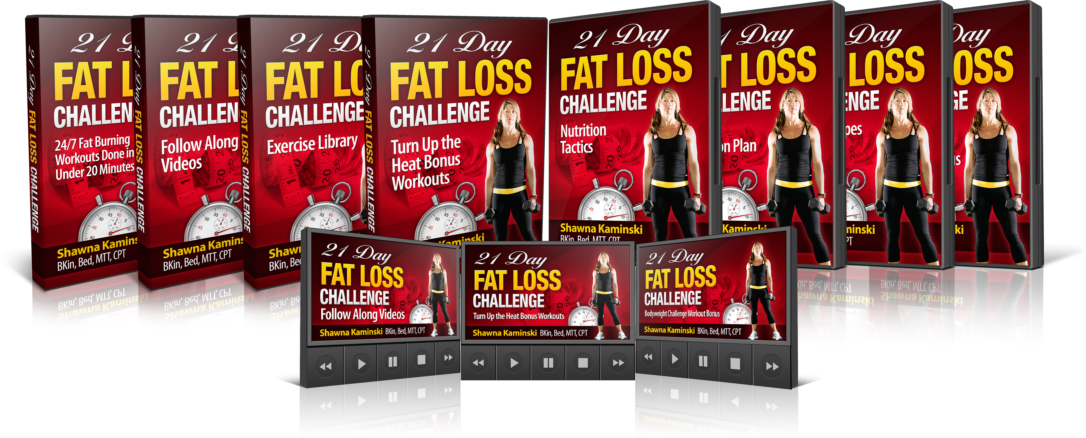

**What does it include?**

\*Updated June 2015

* 12 follow along videos for use at home with minimal equipment
* Print and go workout plans to accompany videos
* Progress assessments and charts
* Exercise library
* **Bonus #1:** Turn Up the Heat Bonus Workouts – another week of video follow along workouts for those that want to add an extra workout each week
* **Bonus #2:** Fat Loss Challenge Nutrition Tactics – My guide to proper eating for optimal performance AND fat loss
* **Bonus #3**: 28 Day Fat Loss Challenge Nutrition System (follow along diet plan)
* **Bonus #4**: 30+ Paleo Fat Loss Challenge Approved Recipes (to use with plan)
* **Bonus #5**: Bodyweight Bonus - 5 more video follow along workouts using just bodyweight
* Currently Split Testing $25/$29

**What are the upsells?**

**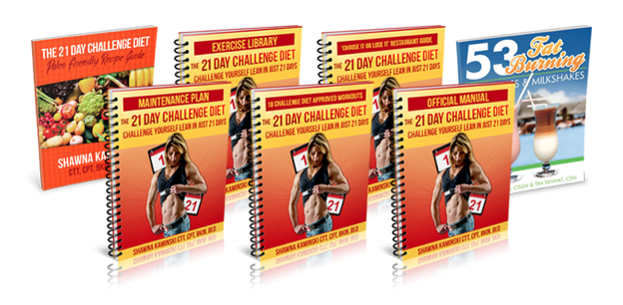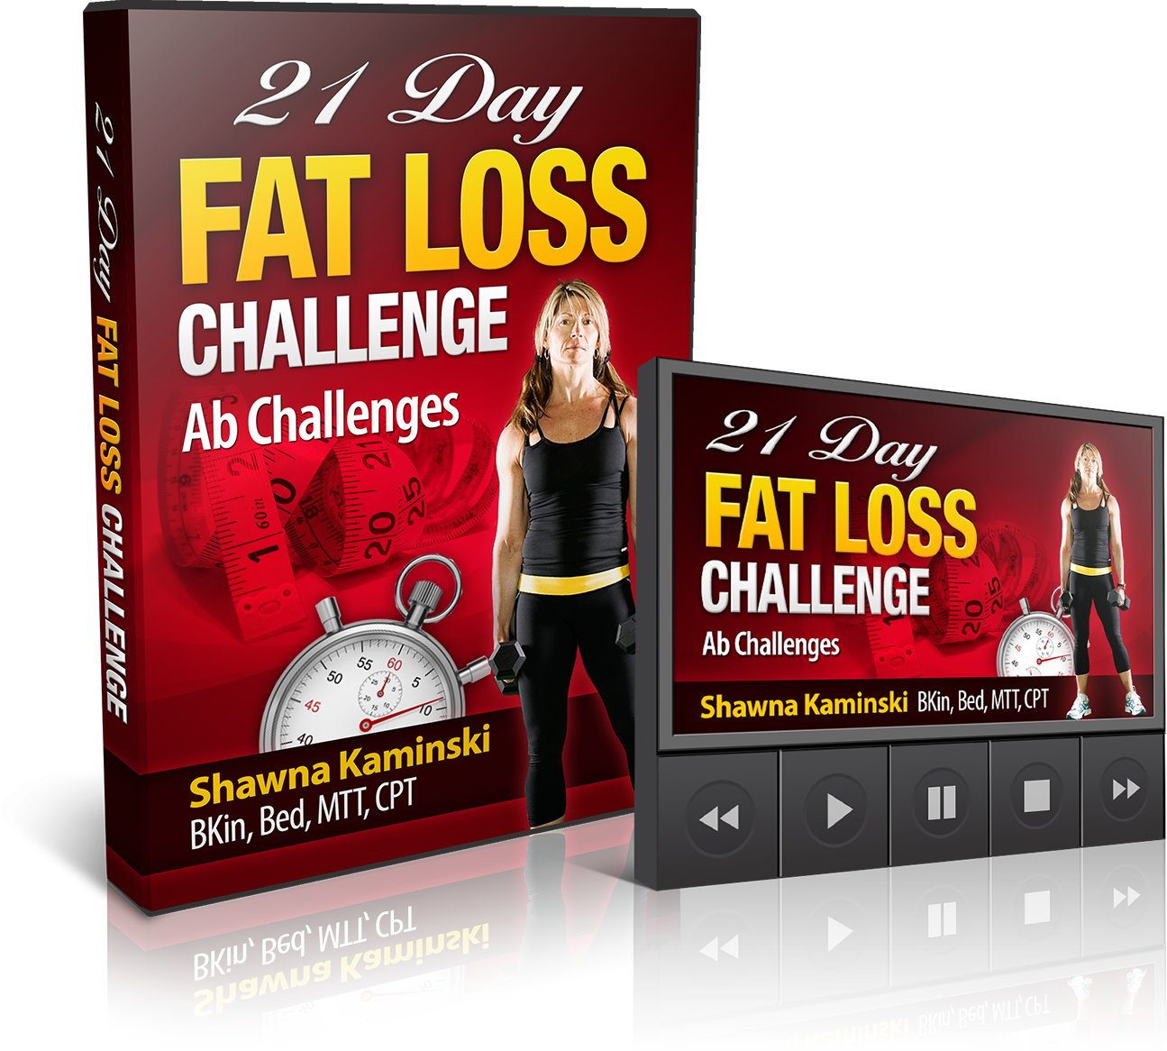**

* **Upsell #1**: 21 Day Challenge Diet Entire program
* **Bonus for upsell #1**: The Ab Challenge 3 more video follow along workouts
* **Price**: split testing $25/$29

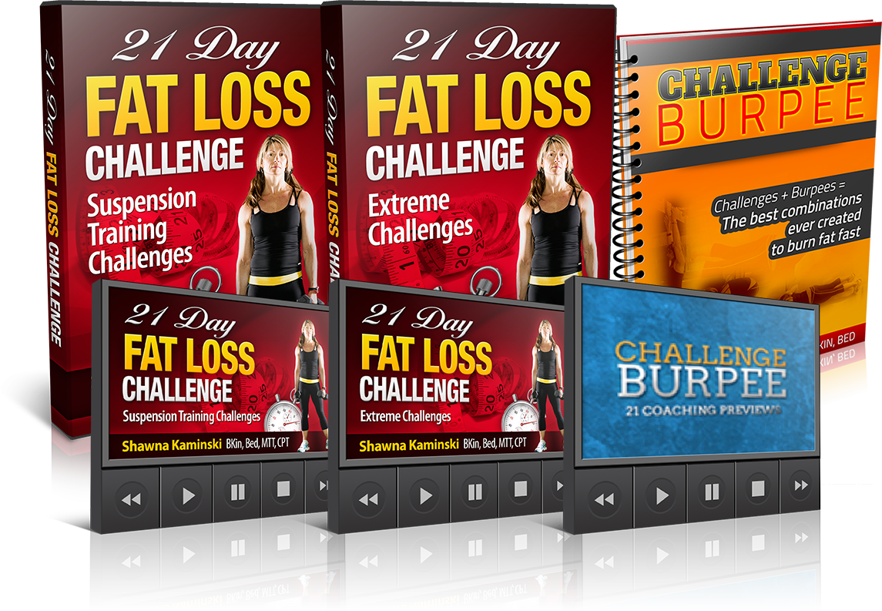

* **Upsell #2**: Fat Loss Challenge Accelerator Bundle
* Ab Challenge video follow along workouts (3) + $27 Suspension training challenge videos (3)
* **Bonus for upsell #2**: Entire Challenge Burpee program
* Split testing $19/$25

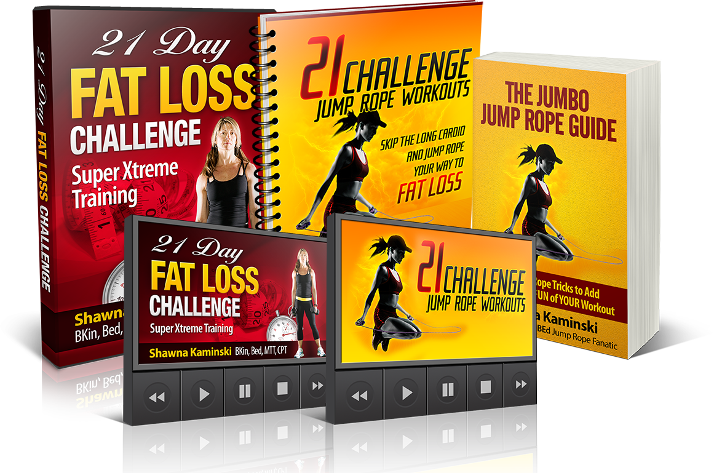

* **Upsell #3**: Challenge Workout SXT – Super Extreme Training package with 8 more video follow along workouts and 5 Challenge Fat Loss Finishers
* **Bonus for upsell #3**: Entire Challenge Jump rope program
* Split testing $14/$19

**Challenge Fat Loss** was the original program. Here are the stats for it:

**Sales Statistics from 2013 Launch:**

Conversion rates for my launch May 7-10th of 2013

Joel Marion– 3.9%

John Rowley – 4.0%

Mike Whitfield – 4.2%

Shaun Hadsell – 5.4%

Shawna K (female fat loss over 40 list) – 7.6%

Adam Steer – 7.8%

Dan Long – 9.4%

Earnings per hop for top affiliates on Friday May 10th 2013:

Joel Marion– $0.55

Shawna K (female fat loss over 40 list) - $0.59

Shaun Hadsell – $0.63

Adam Steer - $0.67

John Rowley – $0.70

Dan Long - $0.93

Mike Whitfield – $0.98

Tyler Bramlett - $1.06

**Average upsell conversion rates:**

Upsell #1 – 31%

Upsell #2 – 19%

Upsell #3 – 21%

**2014 Update on Re-Launch:**

• The average conversion rate for those in the top ten was **5.3%**

• Upsell 1 converted at 28%

• Upsell 2 and 3 held strong at 10% each

• Overall there were just **over 1500** front end sales

**2015 update** – starting to do rolling promos, so far (before updated copy etc):

Mike Whitfield 3.6%

Bruce Krahn 6.0 %

Dan Long 5.4%

**Proven Swipes**

**Affiliate link:**

[**http://cbaffid.1ruckus.hop.clickbank.net/?id=cfl**](http://cbaffid.1ruckus.hop.clickbank.net/?id=cfl)

**NOTE – REPLACE cbaffid with YOUR clickbank name**

**Email #1**

**Subject options: The cure for your slow metabolism**

**How to fix your slow metabolism (not what you think)**

**New metabolism “trick” to use with workouts**

**Why your workouts don’t work anymore…**

If you think that all you have to do in order to lose fat is to burn more calories than you consume…

**… sorry, you’re wrong.**

Think about it – if it were that easy, wouldn’t we all be walking around with six-pack abs and without the thousands of books on diet and exercise?

And no, you don’t have to work out more to burn more fat, that’s a lie too. Although on paper, that seems the most obvious thing to do.

In fact, it’s why we end up even more frustrated… we work out longer and still… NOTHING.

This is especially true as we age… But because of how our hormones work as we get older, working out longer can actually cause you to **STORE more fat.**

The “bad guy” hormone is cortisol, a hormone **that actually PROMOTES fat storage** AND muscle breakdown. And longer workouts create more of this hormone in your body. Now if you’re 19 and have a flat and toned tummy, you probably don’t have a problem with cortisol. But for most of us, those days are gone, and so our workouts need to change.

So if you’re not seeing the results in the mirror, it’s not your fault. You simply just need to “shift” your hormones into fat burning mode with *shorter* workouts. But it’s not as simple as just cutting your workouts short.

To maximize your fat burning and muscle sparing hormones like growth hormone, you’ll need a combination of strength training and “just enough” high intensity interval training (HIIT). Too much of HIIT can have a negative effect, too.

When you use the perfect combination of these two approaches, you can actually fix your “slow” metabolism, which is holding you back from finally taking that stubborn layer of fat off. These simple shifts in your workouts can easily double your results.

==> **Discover this metabolism fixing “trick” here**

On that page, you’ll also see Shawna Kaminski, who uses these EXACT tricks to have flat, toned abs and she can even knock out 25 pull-ups straight.

**By the way, Shawna is 52 years old and smoking hot!**

You’ll also discover her brand new systematic approach to shift your hormones with science-based 20-minute workouts with the PERFECT blend of high intensity interval training and strength training that promotes fast fat loss and NOT cortisol like other programs. It’s all a part of her new 21 Day Fat Loss Challenge program.

In addition to all of her **FOLLOW-ALONG** Fat Loss Challenge workout videos, she’s also giving you 5 fast action bonuses (including a 28 day nutrition plan and recipes so you’ll have the exact plan you need to drop those extra pounds).

**Act fast**==> **Work out with Shawna PLUS get 5 bonuses**

Now you can discover exactly how, rep-by-rep, to work out LESS and optimize your hormones to finally burn fat at ANY AGE. After all, if Shawna can be ripped at 52 and knock out 25 pull-ups, imagine what you can do with her workouts…

==> **21 Day Fat Loss Challenge Workouts PLUS 5 Bonuses FREE**

SIGN OFF

===========================================================

**EMAIL # 2 (SAME DAY – BETWEEN 3PM AND 4PM)**

**Send the SAME email as you did this morning but with one of the following**

**subject line** [Link Fixed] Get the download on the 21 Day Fat Loss Challenge here

**EMAIL # 3**

**Subject options:**

**Change this ONE thing in your workouts**

**3 reasons you’re not losing fat**

**Shocking M2A workouts (results in 20 minutes?)**

You already know that you can’t out train a bad diet. That’s why you need a recipe, a plan to dice up your abs so you’ll feel confident to be seen on the beach. And it’s MORE than just a workout plan.

If you just “workout”, you could actually increase your cortisol, which will force your body to store more fat. You don’t want that.

You see it all the time. People work their butts off (figuratively that is, because at the end of the day their flabby butt is *still* there). They train and wonder ‘why am I *not* getting lean?’

Let me tell you why…three reasons:

**#1 Backward Body Composition**

People just like you and I trade fat for muscle as we age. This tanks our metabolism because our muscle is metabolically active while fat is dead ugly weight.

Unfortunately, it’s easier to lose muscle than it is to lose fat. Our bodies PREFER to use lean muscle tissue for energy over our belly fat.

But with a strategic combination of high intensity interval training, strength training and a nutrition plan that works synergistically with these workouts, you can actually force your body to harness belly fat as energy buy putting your metabolism into Afterburn.

**Discover these “Afterburn” producing workouts and nutrition plan here**

**#2 Hormone Havoc**

Fat storing hormones like cortisol wreak havoc with belly fat and in today’s high stress world this hormone is at an all time high. Hormones that can promote fat burning like growth hormone and testosterone (women should have a healthy level of testosterone as well) decline with age but can be naturally boosted with the *right* kind of exercise. (This does NOT include things like running on the treadmill that actually increase fat storing hormones like cortisol.)

**#3 Poor Eating**

No matter what your exercise plan, if you’re not backing it up with solid nutritionally dense food, your plan will fail. And when it comes to eating, failing to plan is planning to fail, especially when your diet is too restrictive.

That’s why my friend, Shawna K who is more ripped and in better shape than most 20-year olds (she’s 52!), included an entire ‘read it and eat it’ done for you nutrition plan along with her Fat Loss Challenge Nutrition Tactics her **21 Day Fat Loss Challenge** program that uses a brand NEW M2A method.

Other diet plans are too restrictive and don’t allow any wiggle room. Now when you use a combination Shawna’s workouts that manipulate your hormones to promote fat loss and her nutrition plan and tactics to speed up your metabolism, you’ll see rapid results, no matter your age – Shawna is living proof.

Her workouts are only 20 minutes long, which is why they work so well. They promote the “good” hormones, while reducing the fat-storing hormones like cortisol because the workouts are so short.

However, they STILL use a combination of high intensity interval training and strength training. How is this possible? It’s because she uses M2A, which is a new science-based approach that allows you to work out in only 20 minutes but still getting results as if you worked out for 60 minutes.

When you team up **M2A (Muscle Metabolism Acceleration)** along with her nutrition plan, you’re in for a total body transformation.

But it won’t be easy…

This is a workout program that will challenge you every step of the way, but in progressive ways. Best of all Shawna is going to be there with you through every exercise, every set, and ever rep right there with you to motivate, coach and guild you with her follow along videos.

You’ll make small manageable changes to your eating plan and you’ll use the **M2A** system to build lean, athletic muscle and naturally increase fat burning hormones like GH and testosterone and reduce fat storing hormones like cortisol…

… in only 20 minutes per workout!

The workouts are scientifically based and proven. You can get all of Shawna’s M2A workouts and her 21 Day Challenge Fat Loss Nutrition Plan (plus 4 more bonuses!) for less than half the cost of one session with a mediocre trainer.

**Train with the best and get your 20-minute follow-along M2A workouts here**

SIGN OFF

============================================================

**EMAIL #4 (OPTION 1)**

**Subject options:**

**20-minute workout inside**

**This 20-minute workout (accelerates metabolism for 37 hours)**

**M2A 20-min workout (better than 60 mins of cardio)**

Of course you know that muscle is key to the fat burning process. Muscle is more ‘dense’ than fat meaning that it takes up less space in your jeans. Your body weight may drop or even stay the same weight, but your shape will drastically change.

And change is what it’s all about. Who cares what the scale says if you’re looking better naked and not ashamed to lift up your shirt and show off your abs.

But when you strength train too long to get that lean, sexy muscle, you can run into overtraining PLUS encourage cortisol, **which is the hormone that promotes fat storage.**

There’s a new method called **M2A (Muscle Metabolism Acceleration)** that incorporates anaerobic training and strength training in the specialized combinations needed to promote extreme fat loss without and ultimate leanness.

Incomplete workout recovery for lactic acid and GH production paired with strength training moves will boost your fat burning hormones and reduce your fat storing hormones – big time.

Where can you learn more about **M2A?**

My good friend, Shawna Kaminski explains it all and she busts 7 fat loss myths that you probably believed… until now.

**Discover these 7 fat loss myths here**

And when you discover these myths, you’ll also want to IMMEDIATELY get started with Shawna’s workouts based on **M2A** science…

… like this one:

KB or DB Swing (35 seconds)

Spiderman Pushups (35 seconds)

Goblet Switch Lunge (35 seconds)

Pull-up (35 seconds)

Sit-out (35 seconds)

Plank (recovery) (35 seconds)

Do 5 rounds with 7 seconds of transition time between exercises.

But these tough workouts will be better with follow-along videos. You can work out with Shawna coaching you every rep of the way **right here**.

Even though Shawna is 52 years old, she’s literally the oldest hard body I know, she looks and performs like a woman easily 20 years younger. Her secrets WORK.

Not only do these workouts last only 20 minutes and use JUST THE RIGHT amount and combination of high intensity interval training and strength training, but they are all on follow-along videos that you can save to your computer, IPad, Tablet or phone.

You’ll get expert coaching every step of the way, it’s just like having a coach right in your living room with you doing every exercise, set, and rep with you.

**Discover the 7 myths of fat loss here**

And while you’re there, grab Shawna’s 21 Day Fat Loss Challenge Workouts along with her nutrition secrets and 5 bonuses that help her and her clients get and stay ripped all year round.

SIGN OFF

**P.S.** Shawna’s program manipulates your hormones to promote fat loss in 20 minutes or less is the perfect solution for you to lose fat just in time for summer.

==> **Get the 21 Day Fat Loss Challenge + 5 bonuses here**

============================================================

**EMAIL #5 OPTION 2**

**Subject:** The EXACT routine that will get you abs NOW

**Body:**

I want to give you a chance to get your hands on the EXACT program you need to get your abs ready to show off on the beach.  
  
This guide will provide the *perfect* workouts to use on a weekly basis so you can hit the sweet spot of fat-loss week after week...   
  
WITHOUT plateauing OR stressing your adrenal glands, which release too much cortisol with long workouts.

=>**Grab the 21 Day Fat Loss Challenge here**  
Here’s exactly how it works.   
  
When you use Shawna’s 20-minute workouts, you’ll automatically "shift" your hormones into *fat-burning* mode WITHOUT stressing out your adrenal glands which release fat-storing cortisol with long workouts.  
  
...And it has nothing to do with just shortening your workouts.   
  
Inside this system you’ll discover a brand new science   
based breakthrough called M2A.   
  
This extreme fat-burning method strategically "spares" hormones, like growth hormone, by using a specific combination of strength training and *"just enough"* high intensity exercise to hit the SWEET SPOT of fat-burning.   
  
==> [20 minute EXTREME fat-burning breakthrough](https://getleanin12.infusionsoft.com/app/linkClick/6805/22758361338724ef/23475385/c9d717adc40ddf62" \t "_blank) <------ do NOT click yet   
  
Now you can follow along as Shawna takes you through her **M2A** workouts right in the comfort of your own home.   
  
*- NO need to spend time in traffic.*   
  
*- NO need for fancy equipment.*   
  
*- NO excuses.*   
  
Just get your workout done in 20 minutes or less.   
  
Now in the end, you might end up hating Shawna too, because she’s going "push" you beyond your comfort zone.   
  
BUT, you’ll love how you look for summer when you use her **M2A** workouts.   
  
So do yourself a big favor.   
  
**Grab the 21 Day Fat Loss Challenge** and get ripped in just 20 minutes a day.   
  
==> **Grab the 21 Day Fat Loss Challenge here**

***The way I see it you basically have two choices...***   
  
**CHOICE #1:** Wait until summer gets here, get a bit fatter, regret you didn’t take   
action sooner, and try your best to get in great shape AFTER summer is already here.   
  
**OR...**   
  
**CHOICE #2:** Start using *Shawna’s 21 Day Fat Loss Challenge Workouts* today and take advantage of the PERFECT plan and strategy to guarantee you’ll be ready for summer.   
  
Hmmmm...seems like an OBVIOUS choice to me. :-)   
  
Get the entire system and thank me later:   
  
==> [Get your body ready for summer starting now](https://getleanin12.infusionsoft.com/app/linkClick/6809/cfc8cd71f2ad45ce/23475385/c9d717adc40ddf62" \t "_blank)   
  
Remember...it’s either the pain of taking action RIGHT now, ***or*** the pain of regret after summer hits.

Sign off

**P.S.** Shawna’s program manipulates your hormones to promote fat loss in 20 minutes or less; it’s the perfect solution for you to lose fat just in time for summer.

==> **Get the 21 Day Fat Loss Challenge along with 5 BONUSES**

============================================================

**EMAIL # 6**

**Subject options:**

**Ten 20-min workouts you MUST do**

**Ten 20-min workouts that are better than 60 mins of cardio**

**Do these 20-min workouts first (you’ll love # 2)**

Everyone wants to be leaner, stronger, and have fully defined abs. Me too. So I figured I’d give my friend Shawna K’s 21 Day Fat Loss Challenge workouts a go.

It’s based on the science of **M2A.** The basis of the program is centered on increasing lean muscle, increasing metabolism and increasing fat burning hormones like GH and testosterone but WITHOUT cortisol, which is the hormone that promotes fat storage. (And yes, if you’re a woman you have testosterone too, and you need it to burn fat and look and feel your best).

The beauty of the workout is that it’s SHORT (that’s part of the secret to avoiding cortisol). And thank goodness for that. It means that you can really PUSH yourself for the short amount of time it takes to work the fat burning magic of **M2A** – which is like Afterburn on steroids**.**

I figured I’d give you my top ten list from the 21 Day Fat Loss Challenge program. These are some of my favorite ‘love-to-hate-but-love-the-results’ workouts:

**Get all of her M2A workouts here** <== **plus get 5 bonuses!**

1. **What Can You Do with a Bench?** You may want to throw the bench out the window by the end of this leg/butt blaster, but your legs will thank you after this one.
2. **Hot Mess** – Counting down from ten reps to one will leave you in a major sweaty mess. All done in 20 minutes.
3. **I’m Soxy and I Know It** – Nothing but a pull up bar, a bench and sexy socks for super power. Four exercises, modified as you need, will get you sexy for real.
4. **No Cryin’ Allowed** – You’ll use a jump rope, a kettle bell or a dumb bell for a full body workout that will bring you close to tears ;)
5. **Lucky #7** – You may not feel so lucky during this AMRAP (as many reps as possible) workout. But ‘luck’ really has nothing to do with the science of **M2A** that will get you lean and strong.
6. **Beat This!** – Do you like to compete? This is a great workout you can use to compete with yourself. You’ll hit every muscle of your body and raise your metabolism through the roof, even long after your workout is done.
7. **Up by Five –** Counting by five has never been so tough. But the results are well worth it.
8. **Burpee This!** – Thisis called ‘Challenge Fat Loss’ for a reason. Burpees and chin ups? Oh my. The good news is there’s an alternative for every challenging exercise so anyone can succeed and be challenged at your own level.
9. **You’re Suspended** – You ‘love to hate’ the bonus workouts like this one for the suspension trainer that will blast your core especially.
10. **Total Suspension Chaos** – Here’s another favorite total body workout for the suspension trainer. You’ll get three bonus suspension trainer workouts that utilize **M2A** scientific principles.
11. OOPS! One more – **The Pull up Punisher** – I don’t know how I forgot this one, it’s named appropriately, if you love pull ups, you’ll love this challenge.

These are just eleven of my favorite workouts that you can grab right now at 50% off… but only today.

**Get all of Shawna’s workouts here** <== **plus all 5 bonuses!**

Follow along as Shawna takes you through her **M2A** workouts right in the comfort of your own home. No need to spend time in traffic, no need for fancy equipment.

No excuses. Just get your workout done in 20 minutes or less.

You’ll hate Shawna too, but you’ll love the results you’ll get with her **M2A** workouts.

**Grab the 21 Day Fat Loss Challenge** here and get ripped in just 20 minutes a day, giving you more time with your friends and family this summer.

SIGN OFF

=============================================================

**EMAIL # 7**

**Subject options:**

**The BEST 10 workout approaches**

**Top Fat Loss Workouts (#4 is controversial)**

If fat loss were “easy” you’d see more hard bodies, less people buying diet sodas and fat loss books and everyone would look better without the frustrations.

Everyone is looking for the ‘magic bullet’. Fat loss trends come and go and most people get on the bandwagon of the ‘fitness flavor of the month’ and never meet their fat loss goals.

It’s too bad.

See, fat loss actually takes less time than you think with a little hormone manipulation and some workout intensity.

Let’s go through the TOP TEN popular fat loss methods. The measuring stick here is whether these workouts are effective enough to cause noticeable body transformation evidenced with inches and pounds lost.

Before we dive in, I wanted to remind you of these awesome workouts I’ve been talking up all week:

**20-Minute Follow-Along Fat Loss Challenge Workouts** <== **plus 5 bonuses**

10. **Diet alone** – Diets work. People lose weight on diets and can temporarily become smaller versions of their former self. They often get ‘skinny-fat’ and are disappointed that through diet alone they haven’t achieved the body of their dreams. Their metabolism usually tanks, they start eating more and gain more weight than they originally needed to lose. Bottom line: diets *don’t* work long term.

9. **Walking** (and other ‘low intensity’ activities) – People mistake basic movement for exercise. Too many people think that just being ‘upright’ and moving will burn enough calories to make a difference and cause a body transformation. Walking is better than sitting or lying down, but not much.

8. **Zumba** (and other ‘dance related’ workouts) – I know this will cause a stir and Zumba enthusiasts will protest. Zumba is FUN. But let’s not confuse fun with fitness benefits that will cause enough metabolic mayhem to produce a body transformation. Recreation? Yes. Fitness go-to? No. This is great as a ‘day off’ workout.

7. **Running** – How many people resolve to get fit and immediately decide to run a marathon? Have you seen the physique of marathon runners? It may not be what you’re aspiring to. Running will get your heart fit, but will do little to transform your physique so that you’re ready for the beach. If skinny-fat, no muscle tone or upper body shape and repetitive use injury risk is what you’re going for, then running is for you.

6. **Big box gym ‘classes’** – While gyms have good intentions with their fitness classes you’ll be lost in the crowd. You’ll be given a ‘one size’ fits all program that won’t take into account your fitness level, limitations or goals.

5. **Traditional bodybuilding** – Muscle is where it’s at to build metabolism and get sexy shape, but unless you were born to the right parents and are genetically gifted, traditional bodybuilding workouts will fall short. How many people go to the gym and look the SAME as the day they started? They may lift more weight on their bicep curl, but overall their body won’t look like they’re ready to hit the stage anytime soon.

4. **Crossfit style training** – This style of training is getting closer to the intensity needed to affect change. The lack of progressive programming is the downfall of this program. Again, this will raise hell with avid ‘cross-fitters’ but you can’t argue with the number of injuries incurred with any crossfit style workout.

3. **Boot camp style training** – This is hit or miss depending on the actual program. Some programs are BANG ON with 30 minute workouts that are basically personal training in a motivating and supportive group setting. Others? Not so much. Depending on the boot camp you attend, this can be one of the BEST workouts or it can set you up for an injury waiting to happen. Good luck with this one.

2. **P90X style training** – Good programming…if you have A LOT of time. You’ll get variety and intensity, paired a with nutrition plan. As well, follow along videos are a great bonus to teach you exercise form. But who has the kind of time required for this workout plan?

1. **M2A or muscle metabolism acceleration** - The beauty (and the curse) of this workout is that it’s short but intense. The idea is to combine strength training and high intensity intervals with incomplete recovery. Loads of calories are burned *during* the workout, but then ‘*afterburn’* kicks into effect to keep your metabolism stoked for up to 36 hours. **M2A** taps into the anaerobic energy system to stimulate lactic acid. If you didn’t know, lactic acid is a powerful precursor to growth hormone and GH (growth hormone) is diabolical in the fight against fat.

Since adults are well past the age where they’ll experience a natural boost in GH, this is one of the best ways to burn fat and build muscle. **M2A** will also increase lean muscle. The more lean muscle, the higher your metabolism so you can burn more fat and calories even at rest…

… but WITHOUT the cortisol. That’s the secret of these workouts.

**Get all of Shawna’s secrets here** <== **plus 5 bonuses**

One of the number one objections to *any* fitness program is ‘I don’t have time’. The good news with **M2A** isthat workouts are done in 20 minutes or less.

Her follow-along workouts PLUS her step-by-step nutrition program will decrease bad hormones like cortisol (the stress hormone), but it will increase good hormones like growth hormone which promotes fat loss.

**Manipulate your hormones with these workouts**

SIGN OFF

**ADDITIONAL SWIPES:**

**Affiliate link:**

[**http://cbaffid.1ruckus.hop.clickbank.net/?id=cfl**](http://cbaffid.1ruckus.hop.clickbank.net/?id=cfl)

**NOTE – REPLACE cbaffid with YOUR clickbank name**

**Email #8**

**Subject options: Oops, my mistake**

**Sorry about this, try again**

**Re: your request**

It was brought to my attention that the link to the 21 Day Fat Loss Challenge had some issues yesterday and some of my subscribers had a hard time getting the popular program.

So if you missed out on picking up the 21 Day Fat Loss Challenge program, I wanted to remind you about it…

I’ll tell you a little about Shawna in case you missed my talking about her this week…

First, how are you at guessing someone’s age?   
  
It’s a pretty tricky thing to do, right? My strategy is to always guess a little younger than the person looks so as to avoid an inevitable awkward moment if I guess too high.

But, I legitimately figured that Shawna must be in her early 30’s.   
  
Well, I was SHOCKED to hear her real age is 52 and she’s rock’in an amazing body and a tight washboard abs.

In fact, you can see a picture of Shawna’s abs – not something many 52 year olds would dare to show…

Click Here To See Her Picture and to Learn About Her M2A Training System.

I mean, what 52-year-old woman can do the human flag and 50 pull ups in under 5 minutes? *And* have year round ripped abs?

Shawna gets so many questions about her fitness secrets that she put her M2A method of training into a program with follow along videos. She uses a special mix of strength training to build lean muscle tone and high intensity anaerobic intervals in workouts that are 20 minutes or less in her 21 Day Fat Loss Challenge program.

You’ll be a ‘Hot Mess’ (actually the name to one of her workouts ;) in no time. The cool thing is that you’ll continue to burn calories long after your workout is done when you follow along with her. You’ll get expert coaching every step of the way, it’s just like having Shawna coaching you right in your living room.

**Grab Shawna’s 21 Day Fat Loss Challenge Workouts**, along with her nutrition secrets (and 5 bonuses) that help her stay ripped all year round.

SIGN OFF

PS. Shawna sort of takes away everyone’s excuse that age, gender and lack of time are good reasons to be out of shape this summer…are you ready to give up YOUR excuses?

**Affiliate link:**

[**http://cbaffid.1ruckus.hop.clickbank.net/?id=cfl**](http://cbaffid.1ruckus.hop.clickbank.net/?id=cfl)

**NOTE – REPLACE cbaffid with YOUR clickbank name**

**Email #9 (only works if it’s Mother’s day ;)**

**Subject options: I’ll make this quick**

**Even my mom was impressed with this**

I know it’s Mother’s Day, so I’ll be fast.

First of all, Happy Mother’s Day to all of the ‘mom’s’ out there!

I was talking to my mom and telling her about my friend, Shawna who I know is also a ‘mom’.

My mom couldn’t believe that a woman that’s 52, with two kids can have abs like that. (Take a look at her picture here.)

Shawna definitely has a system down to help get her and her clients lean and strong. And it doesn’t require hour-long workouts or starvation diets. It’s a system called M2A training.

You can read all about it here, pretty cool stuff, all backed by science.

**=>21 Day Fat Loss Challenge Fat Workouts + 5 bonuses sale<=**

If for some reason you’re not happy (I can’t imagine why that would be), she’s offered a money back guarantee. You have nothing to lose, but maybe your belly fat…

Have a great day; hope you can honor your mom in a special way…

SIGN OFF

**My awesome affiliates have shared some of their best converting emails – make sure to personalize them for YOU.**

**Best converting emails from 2014:**

From Shaun:

## Subject: "Wake Up" your DEAD adrenal glands (here's how)

Your adrenal glands dictate the release of certain hormones   
that control fat-loss and they typically respond best to high   
intensity stimuli like intervals, sprints, or short-hard bursts.   
  
But too much exercise and life stressors can cause severe   
Adrenal Fatigue, which can destroy your energy, motivation,   
and kill your results.   
  
**That’s why it’s often referred to as the 21st Century Stress**   
**Syndrome.**Each of your adrenal glands sits right above your kidneys and they are   
arranged in 3 different layers.   
  
LAYER 1: Your outermost layers control your sodium and your   
electrolyte levels.   
  
LAYER 2: The middle layer controls sugar and generates stress   
hormones.   
  
LAYER 3: The innermost layer generates Growth Hormones and   
sex steroids.   
  
According to doctors the old saying in medical school to memorize   
the three layers is "salt, sugar, sex" – the deeper you go, the better   
it gets :-)   
  
But unfortunately, the three layers are NOT perfectly divided.   
  
If you’re using high-intensity exercise trying to hammer your   
adrenal glands too frequently, your body won’t recover, which   
means you won't tap down into a deeper level.   
  
**So instead of a Growth Hormones spurt, you’ll get a**   
**cortisol spurt, completely defeating the entire purpose.**Here are 4 super easy ways to resolve this common problem   
if you’re feeling a little burned out or can’t recover fast enough.   
  
**4 Easy Ways to AVOID Adrenal Fatigue   
  
Tip #1:** Only use high intensity interval or bursting   
sessions 2 to 3 times per week. **No more**.   
  
**Tip #2:** If you’ve hit a plateau, take a few weeks off high   
intensity exercise and/or intervals and just walk or do low   
intensity cardio 3 to 5 times per week instead.   
  
This will give your body a much needed break and **allow your**   
**metabolism to "reset" and respond better** when you add high   
intensity back in again.   
  
**Tip #3:** Cut back on stimulants like caffeine.   
  
Over time, these stimulants wreak havoc on the adrenals   
and can sometimes even make them non-responsive.   
  
Additionally, you’ll kill your "natural" energy systems and   
experience a daily energy crash in the afternoon.   
  
**Tip #4:** Use workouts that combine resistance training and   
intervals, together, but last NO MORE than 20 minutes to   
prevent adrenal stress and overtraining.   
  
The perfect solution is Shawna Kaminski’s ***Challenge Fat Loss***.   
  
Her 20 minute system gives you the "perfect" amount of high   
intensity training on a daily and weekly basis to MAX OUT   
your fat-loss, without being concerned about Adrenal Fatigue:   
  
**==>** **[20 minute EXTREME M](https://getleanin12.infusionsoft.com/app/linkClick/16073/5d1cd2eba9f97f40/59357827/61de0a19d4060ded" \t "_blank)[2](https://getleanin12.infusionsoft.com/app/linkClick/16073/5d1cd2eba9f97f40/59357827/61de0a19d4060ded" \t "_blank)[A Fat-Burning Breakthrough](https://getleanin12.infusionsoft.com/app/linkClick/16073/5d1cd2eba9f97f40/59357827/61de0a19d4060ded" \t "_blank)**   
  
Keep going strong,

From Shaun H

Subject: The 3 Metabolic Systems of RAPID Fat Loss (STOPS plateaus)

**Unopens Subject:** How I “Cycle” Cardio To Stay Under 10% Body Fat Year

There are 3 different metabolic systems of cardio that you can

easily access on a weekly basis to guarantee you’ll never hit

a weight-lossplateau.

**SYSTEM #1** short high intensity bursts of cardio type exercise

lasting between 20 to 30 seconds with adequate recovery time

between bursts.

**Example:** 20-30 sprint with 1 minute of walking in between.

(repeat 5 to 10x)

**Benefits:** This releases fat-burning hormones (adrenaline etc.)

that help “break” apart stubborn pockets of fat and creates a

huge 24 to 48 “after” burn.

**SYSTEM #2** moderate intensity intervals that last between 60

seconds all the way up to 2-3 minutes at a time with strategic

recovery time between intervals.

**Example:** Push yourself hard for 60 seconds on bike, elliptical,

or treadmill with 1-2 minutes of walking in between.

(repeat 5 to 10x)

**Benefits:** This is the **fastest** way to deplete glycogen, which

always equals faster fat-loss --- and it’s the only system that

has been shown to increase fat-burning results from the *other*

two systems (system 1 and 3).

**SYSTEM #3** is lower intensity cardio done for longer durations

of 30 all the way up to 60 minutes.

**Example:** Jogging or biking at a steady lower intensity pace for

30-45 minutes 1 or 2x per week.

*Although this type of cardio is constantly being bashed, it’s mostly*

*because people chronically overdo it.*

**Benefits:** Using the lower intensity system sparingly will condition

the “aerobic” system properly, which will increase your performance

when using the higher intensity systems 1 and 2.

This system also improves your body’s ability to store and utilize

glycogen (stored energy from carbs), which improves fat-burning

efficiency inside your body.

You can feel free to add each of these protocols to the end of a

weight training sessions, or solely on their own on your off days.

Or just follow Shawna Kaminski’s 20 minute ***Fat Loss Challenge***

***Workout System***and you’ll automatically be applying this strategy

with ZERO guesswork involved.

Her extreme fat-burning method, called **M2A,** “blocks” cortisol

release by using a *specific* combination of strength training and

*“just enough”* high intensity training so you’re guaranteed to hit

to **sweet spot** of fat-loss *every* time you train.

**==> 20 minute EXTREME M2A Fat-Burning Breakthrough**

Just click the link above, check out Shawna’s 51 year old

smokin’ hot body, and you’ll instantly see why she’s the

real deal.

Your friend and coach,

Shaun