7 Moves for Fat Loss
Challenge Fat Loss Workout

If you’re looking for a workout for your blog or want to send one in an email, you’ll find one below.

Here’s the Youtube link: http://youtu.be/tbFS7GDq8wg

Here’s a bodyweight Challenge Fat Loss style workout that is perfect for beginner through advanced people.

Set your timing device for:
Advanced - 40 seconds work/10 seconds rest
Intermediate – 30 seconds work/10 seconds rest
Beginner – 20 seconds work/10 seconds rest

Do these exercises:
- Cross body mountain climber
- Prisoner reverse lunge
- Double jump burpee
- Over head 1.5 squat
- Get up
- Sit out or mountain climber
- Plank alternate leg lift

Rest as needed between sets
Do up to 5 rounds

Here are some photo descriptions that can be used in an email or blog post:

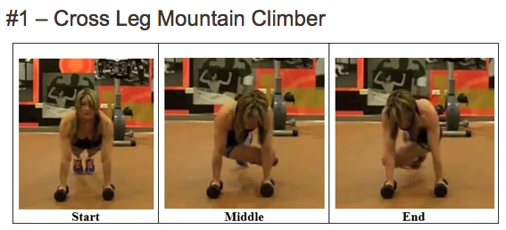
http://challengeworkouts.com/wp-content/uploads/2014/04/cross-leg-mtn-clmbr.png

-High plank position, cross the leg under the body to opposite elbow

#2 - Prisoner Reverse Lunge

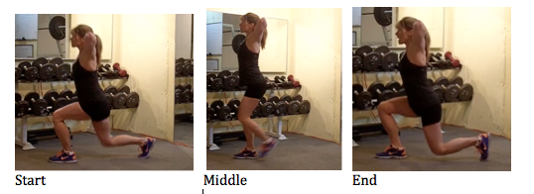

http://challengeworkouts.com/wp-content/uploads/2014/04/pris-rev-lunge-abc.png

-Hands on the head and squeeze elbows back
-Step back with one foot, drop knee to the floor
-Maintain 90 degree angle at the ankle, knee and hip
-Return to standing by stepping up on front heel
-Repeat on the other side

#3 – Double Jump Burpee

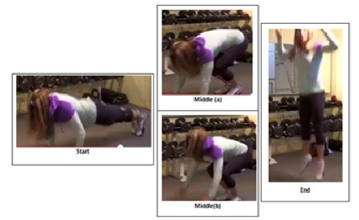
http://challengeworkouts.com/wp-content/uploads/2014/04/burpee-double-jump.png
-Standing position
-Drop hands to the floor, shoot legs back into a high plank
-Squat thrust legs back towards hands and jump, repeat jump

#4 – Over head 1.5 Squat

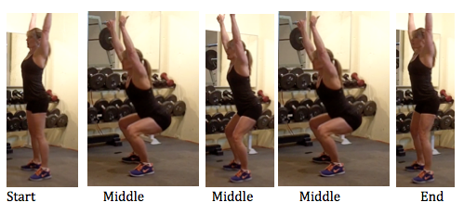
http://challengeworkouts.com/wp-content/uploads/2014/04/OH-1.5-sq-abc.png
-Standing position with arms overhead, elbows straight, hands over shoulders
-Squat hips back to 90 degrees or more
-Come up halfway, go back into full squat position
-Stand up, repeat

#5 – Get Up

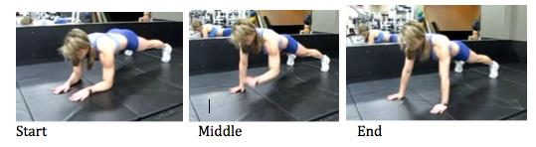
http://challengeworkouts.com/wp-content/uploads/2014/04/get-up-abc.png

-Start in high plank position
-Drop to low plank position
-Alternate the arm that ‘gets up’ first

#6 – Sit Out (or mountain climber)

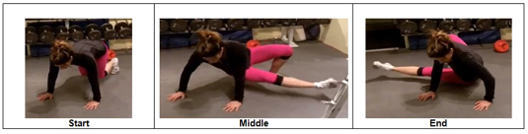
http://challengeworkouts.com/wp-content/uploads/2013/04/sit-out-description.png
-Start in a plank like position with knees close to the elbows
-Rotate hips and shoot extended leg to the side, dropping the hip to the floor
-Optional: lift arm
-Bring the leg back to start postion
-Repeat opposite side

#7 – Plank Alternate Leg Lift

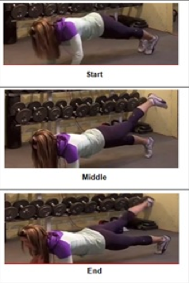
http://challengeworkouts.com/wp-content/uploads/2014/04/plank-alt-leg-lift.png
-Plank position
-Lift one leg at a time slowly alternating

